PROGRAM EVALUATION FOR THE 2022-2023 SCHOOL YEAR
Principal Name: Brenda Gammans
School’s Name: Oak Hill Elementary
Annually evaluating the School-wide plan, using data from the State’s assessments, other student performance data, and perception data to determine if the School-wide program has been effective in addressing the major problem areas and, in turn, increasing student achievement, particularly for the lowest-achieving students. Schools must annually revise the plan, as necessary, based on student needs and the results of the evaluation to ensure continuous improvement. (ESEA section 1114(b)(3); 34 C.F.R. § 200.26(c)).
Directions Evaluate your Title I SWP by using the data provided in your Comprehensive Needs Assessment (CNA) to determine if your goals for each area were met.

2022-2023 Program Evaluation of the School-wide Plan
Goals and Strategies
ELA/Reading
SMART Goal: Students in grades 1-5 will show an increase from Fall 2022 to Spring 2023 of at least 3% in Total ELA NPR scores according to IOWA data.
Smart Goal Met? ☒ Smart Goal Not Met? ☐
Grade Level | BOY IOWA ELA NPR | EOY IOWA ELA  NPR | Gains  Yes or No | Goal Met?
1st | 21 | 39 | Yes | Yes
2nd | 32 | 44 | Yes | Yes
3rd | 32 | 37 | Yes | Yes
4th | 33 | 38 | Yes | Yes
5th | 41 | 52 | Yes | Yes

Summary: The strategies in our plan had a positive impact on student achievement. All grades exceeded their goal of increasing total NPR scores. Grade 1 demonstrated significant growth.
Math
SMART Goal: Students in grades 1-5 will show an increase from Fall 2022 to Spring 2023 of at least 3% in Total Math NPR scores according to IOWA data.
Smart Goal Met? ☒ Smart Goal Not Met? ☐
Grade Level | BOY IOWA  Math NPR | EOY IOWA  Math NPR | Gains  Yes or No | Goal Met?
1st | 32 | 37 | Yes | Yes
2nd | 28 | 45 | Yes | Yes
3rd | 25 | 31 | Yes | Yes
4th | 24 | 28 | Yes | Yes
5th | 26 | 39 | Yes | Yes

Summary: The strategies in our plan had a positive impact on student achievement. All grades exceeded their goal of increasing total NPR scores. Grades 2 &5 demonstrated significant growth.
Science
SMART Goal: Seventy percent of students in grades 1-5 will demonstrate overall mastery of grade level Science content by progressing, meeting, or exceeding the standard or by achieving a minimum score of 70 as the final grade.
Smart Goal Met? ☒ Smart Goal Not Met? ☐
Based on student report card data, what percentage of your students passed science? 94
Based on student report card data, what percentage of your students failed science? 6%
Grade Level | BOY Report Card Summary  Science | EOY Report Card Summary  Science | Gains  Yes or No | Goal Met?  (70 % of students demonstrating overall mastery)
1st | 0 | 87% | Yes | Yes
2nd | 0 | 100% | Yes | Yes
3rd | 0 | 100% | Yes | Yes
4th | 0 | 95% | Yes | Yes
5th | 0 | 86% | Yes | Yes

Summary: The strategies in our plan had a positive impact on student achievement. All grades exceeded their goal of achieving a minimum score of 70 as a final grade. Common assessment rigor needs to be analyzed in comparison to GMAS science proficiency data.
Social Studies
SMART Goal: Seventy percent of students in grades 1-5 will demonstrate overall mastery of grade level Social Studies content by progressing, meeting, or exceeding the standard or by achieving a minimum score of 70 as the final grade.
Smart Goal Met? ☒ Smart Goal Not Met? ☐
Based on student report card data, what percentage of your students passed social studies? 95%
Based on student report card data, what percentage of your students failed social studies? 5%
Grade Level | BOY Report Card Summary  Social Studies | EOY Report Card Summary  Social Studies | Gains  Yes or No | Goal Met?  (70 % of students demonstrating overall mastery)
1st | 0 | 89% | Yes | Yes
2nd | 0 | 100% | Yes | Yes
3rd | 0 | 100% | Yes | Yes
4th | 0 | 98% | Yes | Yes
5th | 0 | 85% | Yes | Yes

Summary: The strategies in our plan had a positive impact on student achievement. All grades exceeded their goal of achieving a minimum score of 70 as a final grade.
Support Areas
Directions: Describe how parent and family engagement, technology, professional learning, and student behavior/attendance influenced student achievement.
Parent and Family Engagement: | Oak Hill had 23 parents respond to the Parent and Family Engagement Survey, 108 family members attended Literacy Night, and 54 family members attended math night.  Parents at Oak Hill are supporters, encouragers, monitors, advocates, decision makers, and collaborators in efforts to increase student achievement. Their involvement contributes to fewer discipline issues, better grades, and higher test scores.  Teachers have benefited from our Parent and Family Engagement program by building staff capacity and developing partnerships with families. These sessions have resulted in higher quality customer service, shared responsibility with parents, and the creation of a welcoming school culture.
Technology: | Technology such as laptops, Chromebooks, Ipads, document cameras, interactive panels, and accompanying accessories have been used to enhance student learning by boosting engagement and addressing various learning styles. The technology was used in conjunction with software programs such as Istation Reading, Brainpop, Nearpod, and ALEKS to help increase student achievement and to help students master standards as evidenced by increased usage throughout the school year, software report data, and end of year report card data.
Professional Learning: | Teachers participated in PLCs led by the Instructional Coach throughout the school year focused on such topics as the role of the PLC, developing common assessments, and preparing for the New GA K-12 Math Standards. Teachers also participated in various sessions provided by district leaders. New teachers participated in monthly professional learning by the BEST teacher leader. Professional learning sessions at Oak Hill have led to increased student achievement and student mastery of standards as demonstrated on the IOWA and end of year report card data.
Student Behavior and Attendance: | Behavior recognition through the WOW program has increased time on-task for students, as well as contributed to a safe and orderly learning environment. Students at Oak Hill understand expectations and interact positively with their peers. Students also experience positive adult influences and a sense of belonging.  Student attendance at Oak Hill continues to decrease. This school year, 41% of students had 10 or more absences. This data does not include the large number of students who missed significant instructional time due to excessive tardiness. Students who attend school regularly demonstrate higher test scores, better grades, and overall increased student learning.

SCHOOL-WIDE/SCHOOL IMPROVEMENT PLAN
School Name: Oak Hill Elementary |  | District Name: Newton County School System
Principal Name: Brenda Gammans |  | School Year: 2023-2024
School Mailing Address: 6243 Highway 212 Covington, GA 30016
Telephone: 770-385-6906
District Title I Director/Coordinator Name: Dr. Andrea Kinney
District Title I Director/Coordinator Mailing Address:
P.O. Box 1469
2109 Newton Drive NE
Covington, GA 30014
Email Address: kinney.andrea@newton.k12.ga.us
Telephone: (770) 787-1330, ext 1248
ESEA WAIVER ACCOUNTABILITY STATUS
(Check all boxes that apply and provide additional information if requested.)
Comprehensive Support School |  | Targeted Support School
Title I Alert School

Revision Date: 7/22/2020 | Revision Date: 6/10/2021 |  | Revision Date: 8/17/2022

DISTRICT STRATEGIC GOALS
- Strategic Goal Area I: Student achievement and success
- Performance Objective A: Increase student mastery of standards
- Performance Objective B: Increase opportunities for students to demonstrate success beyond test scores
- Performance Objective C: Increase graduation rate
- Strategic Goal Area II: High-quality workforce
- Performance Objective A: Improve recruitment process to identify and hire high-quality staff
- Performance Objective B: Increase capacity of staff to deliver and support high-quality instruction
- Performance Objective C: Retain high-quality personnel by cultivating and supporting staff
- Strategic Goal Area III: Culture. Climate, & Communication
- Performance Objective A: Increase effective community partnerships
- Performance Objective B: Improve the quality of two-way communication with all stakeholders
- Performance Objective C: Provide equitable and inclusive learning and work environments at all levels of the district
- Strategic Goal Area IV: Organizational and operational effectiveness
- Performance Objective A: Ensure a systemic culture of safety
- Performance Objective B: Provide high-quality operational and instructional supports
- Performance Objective C: Increase the quality and presence of professional learning communities to improve performance and ensure continuous improvement
- Performance Objective D: Increase effectiveness utilizing performance development/management strategies

Oak Hill Elementary School
2023 Title I Summer Program Planning Meeting
Tuesday, May 30, 2023

Agenda

- Sign-in Sheet and Time Sheet
- Review the District Strategic Plan/CLIP
- Review and analyze data – Include data charts and written analysis in section 1 of Title I Plan
  - Grade-Level Data (GKids, GMAS, IOWA)
  - Core Subject-Area Data (ELA/Reading, Math, Science, Social Studies)
  - Subgroup Data (Required)
  - Parent and Family Engagement Survey Data
  - Attendance Data
  - Behavioral Data
- Complete the 2022-2023 Program Evaluation- Located at the beginning of the schoolwide plan.

- Complete the 2022-2023 Logic Model Evaluation(s)

Oak Hill Elementary School
2023 Title I Summer Program Planning Meeting
Wednesday, May 31, 2023

Agenda

- Sign-in Sheet and Time Sheet
- Revise Title I Schoolwide Plan for the upcoming school year
- Complete the Title I Budget Justification Spreadsheet
- Complete FY24 Staff Justification
- Next Steps

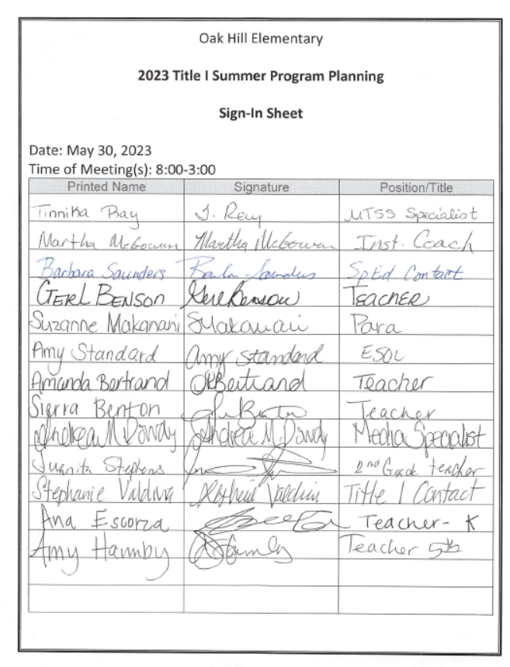
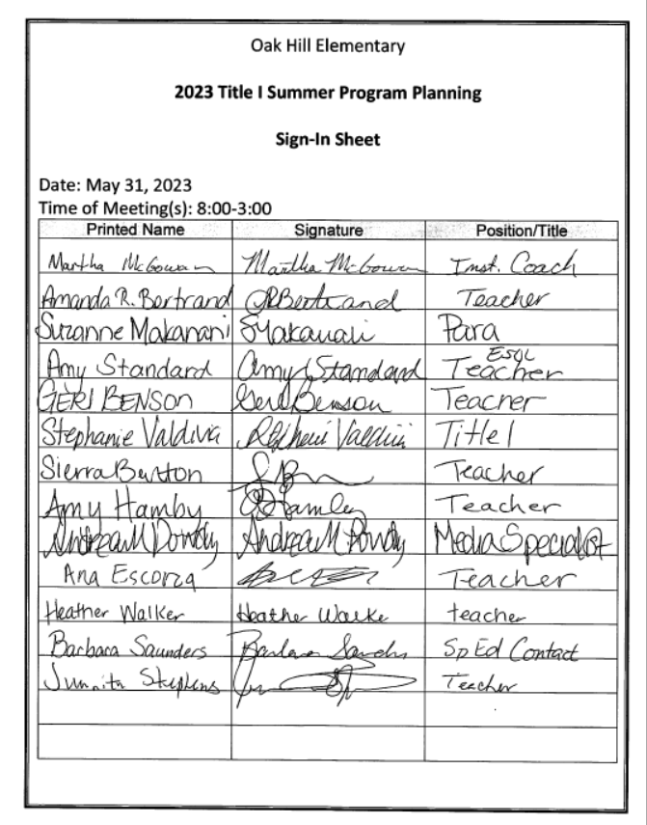
- Comprehensive Needs Assessment – Section 1114(b)(1)(A)
Is based on a comprehensive needs assessment of the entire school that takes into account information on the academic achievement of children in relation to the challenging State academic standards, particularly the needs of those children who are failing, or are at-risk of failing, to meet the challenging State academic standards and any other factors as determined by the local educational agency.
We have developed our School-wide plan with the participation of individuals who will carry out the comprehensive School-wide/school improvement program plan. Those persons involved were…
Response: Those people involved were Tara Lynn, Susie McGowan, Heather Walker, Ana Escorza, Amanda Bertrand, Juanita Stephens, Gerl Benson, Sierra Benton, Amy Hamby, Amy Standard, Andrea Dowdy, Stephanie Valdivia, Suzanne Makanani, and Barbara Saunders. This includes members of the school leadership team which includes a representative from each grade level, administration, ESOL, and special education. Heather Walker was a parent representative. The plan was shared with the school personnel through the leadership team. Parents attended a meeting on March 14, 2023, to give input on the planning of this school improvement plan.

We have used the following instruments to obtain this information . . .
- School Demographics
- GKIDS
- NSGRA Data
- K-3 Phonemic Awareness
- Access Testing
- IOWA Testing
- CogAT Testing
- CCRPI
- Georgia Milestones Data
- Staff Profile
- Additional data sources
- School Climate Charts
- Discipline
- Attendance

School Demographics 2022-2023
Count date 5/19/23

Enrollment | Hispanic | American Indian | Asian | Black | Pacific Islander | White | Multi-Racial | Female | Male
Percentage of students | 15 | 0.6 | 0.2 | 55 | 0 | 10 | 4 | 47 | 53
Total # of students  640 | 95 | 4 | 1 | 349 | 0 | 67 | 24 | 299 | 341

 | Number of Students | Percent of Student Population
Free and Reduced Lunch | *All students received free lunch from a grant this year | n/a
Special Education Enrollment | 150 | 23
Gifted Enrollment | 52 | 8
EIP Enrollment | 180 | 28
ESOL Program Enrollment | 50 | 8
Summary Statement: We have slightly more male students than female. Our subgroups consist of 55 % black students, 15% Hispanic, 10 % white, and less than 5% others. We have 23% of our population receiving Special education services and 28% of our students receiving EIP services.

Mobility Rate (%) | 33.43%

Attendance Rate –% of students with fewer than 6 absences | 31.8%

Retention Rates (percent of students in grade level retained) (as of 5/19/23)
 | Pre-K | Kdg. | 1st | 2nd | 3rd | 4th | 5th
% retained | 0 | 8 | 10 | 0 | 0 | 0 | 0
# of Students retained | 0 | 8% | 10% | 0 | 0 | 0 | 0

Summary Statement: Students were retained from only 2 grade levels with the majority in grade 1.
School Demographics 2021-2022
05/16/22

Enrollment Total | Ethnic  Hispanic | American Indian | Asian | Black | Pacific Islander | White | Multi-Racial | Female | Male
Percentage of students | 14% | 1% | 0% | 53% | 0% | 24% | 8% | 47% | 53%
Total # of students: 641 | 87 | 4 | 0 | 340 | 0 | 156 | 54 | 304 | 337

 | Number of Students | Percent of Student Population
Free and Reduced Lunch | *Not available—Lunch free to all this year per grant.
Special Education Enrollment | 125 | 20
Gifted Enrollment | 51 | 8
EIP Enrollment | 160 | 25
ESOL Program Enrollment | 45 | 7

Summary Statement: We have slightly more male students than female. Our subgroups consist of 53 % black students, 14% Hispanic, 24 % white, and less than 9% others. We have 20% of our population receiving Special education services and 25% of our students receiving EIP services.

Mobility Rate (%) | 30.91

Attendance Rate - % of students with fewer than 6 absences | 33.33%

Retention Rates (percent of students in grade level retained)
 | Pre-K | Kdg. | 1st | 2nd | 3rd | 4th | 5th
% Retained | 0 | 6% | 6.5% | 0 | 0 | 0 | 0
# students | 0 | 7 | 10 | 0 | 0 | 0 | 0

GKIDS 2.0
Student Achievement

2021-2022

Learning Progressions | % Demonstrating or Exceeding
English LA
Phonemic Awareness | 72
Phonics | 69
High Frequency Words | 57
Comprehension | 49
Conventions of Writing | 47
Spelling | 54
Communication of Ideas | 47
Mathematics
Shapes | 29
Counting-Number | 64
Counting-Objects | 75
Compare | 75
Addition and Subtraction | 45

Summary:
Kindergarten students demonstrated a significant increase in phonemic awareness in all areas.
Strengthens were phonemic awareness, counting objects, and comparing. Opportunities for improvement are conventions of writing and shapes.
2022-2023
Learning Progressions | % Demonstrating or Exceeding
English LA
Phonemic Awareness | 66
Phonics | 67
High Frequency Words | 62
Comprehension | 50
Conventions of Writing | 57
Spelling | 60
Communication of Ideas | 56
Mathematics
Shapes | 39
Counting-Number | 66
Counting-Objects | 73
Compare | 72
Addition and Subtraction | 54
Summary of GKIDS data:

Strengths were phonics, phonemic awareness, counting objects, and comparing. The percentage of students demonstrating or exceeding the standard increased significantly in the areas of writing, shapes, and addition/subtraction.

NSGRA Data 2022-2023
 | Kindergarten | 1st Grade | 2nd Grade | 3rd Grade | 4th Grade | 5th Grade | Total
Pre-A | 9 | 2 | 0 | 0 | 0 | 0 | 11
A | 16 | 2 | 0 | 0 | 1 | 0 | 19
B | 7 | 3 | 1 | 0 | 1 | 1 | 13
C | 13 | 7 | 1 | 1 | 0 | 0 | 22
D | 12 | 4 | 0 | 0 | 0 | 0 | 16
E | 11 | 7 | 1 | 1 | 0 | 0 | 20
F | 9 | 10 | 1 | 1 | 1 | 0 | 22
G | 9 | 6 | 3 | 0 | 1 | 0 | 19
H | 5 | 11 | 1 | 3 | 1 | 0 | 21
I | 1 | 4 | 4 | 4 | 2 | 0 | 15
J | 2 | 5 | 1 | 1 | 0 | 0 | 9
K | 2 | 7 | 2 | 1 | 0 | 1 | 13
L | 1 | 16 | 3 | 5 | 2 | 0 | 27
M | 0 | 6 | 6 | 7 | 0 | 2 | 21
N | 4 | 5 | 13 | 11 | 2 | 2 | 37
O | 0 | 4 | 24 | 4 | 6 | 0 | 38
P | 0 | 3 | 8 | 11 | 7 | 0 | 29
Q | 0 | 0 | 6 | 15 | 3 | 1 | 25
R | 0 | 1 | 5 | 7 | 14 | 3 | 30
S | 0 | 0 | 0 | 2 | 12 | 2 | 16
T | 0 | 0 | 1 | 3 | 20 | 4 | 28
U | 0 | 0 | 1 | 2 | 8 | 4 | 15
V | 0 | 0 | 1 | 1 | 7 | 3 | 12
W | 0 | 0 | 0 | 0 | 7 | 2 | 9
X | 0 | 0 | 0 | 0 | 8 | 15 | 23
Y | 0 | 0 | 0 | 0 | 1 | 0 | 1
Z | 0 | 0 | 0 | 0 | 5 | 65 | 70
Total | 101 | 103 | 83 | 80 | 109 | 105 | 581

Key: Below end of year goal At end of year goal  Above end of year goal

NSGRA Data 2021-2022

 | Kindergarten | 1st Grade | 2nd Grade | 3rd Grade | 4th Grade | 5th Grade | Total
Pre-A | 4 | 2 | 3 | 0 | 0 | 0 | 11
A | 14 | 0 | 0 | 1 | 0 | 0 | 14
B | 13 | 4 | 0 | 1 | 1 | 0 | 17
C | 18 | 7 | 2 | 0 | 0 | 0 | 15
D | 15 | 5 | 0 | 3 | 0 | 0 | 14
E | 11 | 2 | 4 | 1 | 0 | 0 | 31
F | 10 | 1 | 4 | 0 | 0 | 0 | 23
G | 4 | 2 | 4 | 0 | 0 | 0 | 15
H | 5 | 4 | 4 | 2 | 1 | 0 | 9
I | 2 | 6 | 0 | 2 | 0 | 1 | 11
J | 4 | 12 | 4 | 2 | 1 | 1 | 14
K | 2 | 9 | 3 | 7 | 0 | 0 | 13
L | 0 | 12 | 8 | 7 | 0 | 1 | 34
M | 0 | 2 | 7 | 6 | 1 | 0 | 12
N | 2 | 15 | 12 | 12 | 4 | 2 | 62
O | 0 | 3 | 18 | 13 | 1 | 0 | 35
P | 2 | 2 | 11 | 8 | 4 | 2 | 26
Q | 1 | 0 | 7 | 5 | 3 | 0 | 19
R | 0 | 1 | 2 | 12 | 3 | 4 | 29
S | 0 | 1 | 1 | 4 | 9 | 1 | 31
T | 0 | 0 | 0 | 7 | 32 | 3 | 31
U | 0 | 0 | 0 | 4 | 7 | 1 | 9
V | 0 | 0 | 0 | 1 | 8 | 12 | 30
W | 0 | 0 | 0 | 1 | 8 | 1 | 13
X | 0 | 0 | 0 | 0 | 7 | 5 | 33
Y | 0 | 0 | 0 | 0 | 10 | 3 | 10
Z | 0 | 0 | 0 | 0 | 0 | 50 | 77
Total | 118 | 98 | 95 | 103 | 104 | 120 | 638

NSGRA Grade Level Summaries

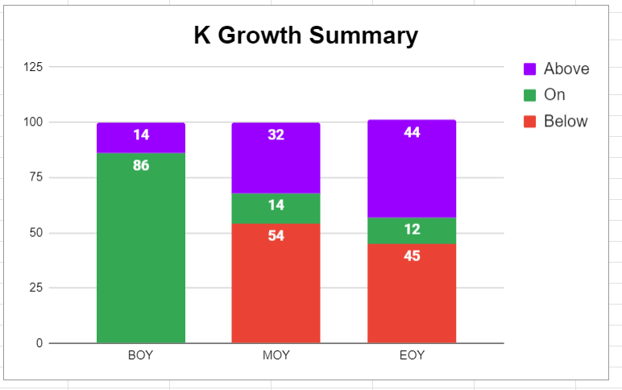

EOY yearly comparisons | Below | On | Above
2022-2023 | 45 | 12 | 44
2021-2022 | 46 | 15 | 40
2020-2021 | 64 | 12 | 24
Summary of Data: Grade K students demonstrated growth from beginning to end of year. The percentage of students exceeding the benchmark increased this year. Roughly 55% of the students did not meet the NCSS benchmark of Instructional Level D. The Scholastic NSGRA Platform reports Level C as on grade level for grade K and 69% of our students met or exceeded level C.

EOY yearly comparisons | Below | On | Above
2022-2023 | 54 | 5 | 41
2021-2022 | 37 | 13 | 50
2020-2021 | 55 | 8 | 37
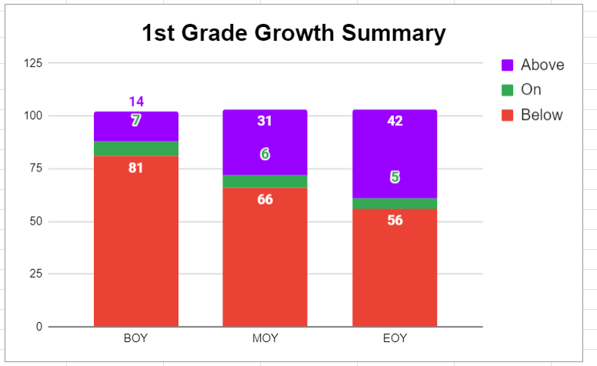

Summary of Data: Grade 1 students demonstrated growth from BOY to EOY. The percentage of first graders who met the EOY benchmark was less compared to the previous school year.
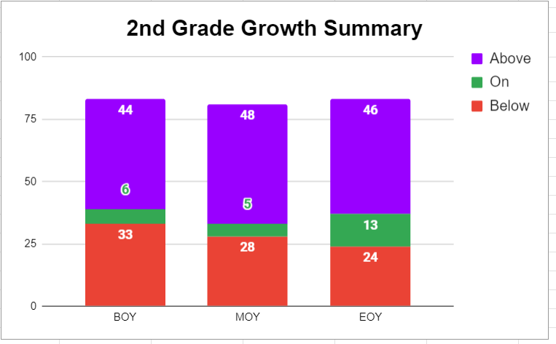

EOY yearly comparisons | Below | On | Above
2022-2023 | 29 | 16 | 55
2021-2022 | 46 | 13 | 42
2020-2021 | 52 | 9 | 40

Summary of Data: Grade 2 students demonstrated growth from BOY and EOY. The percentage of students meeting the benchmark was significantly greater than in the last two years.

EOY yearly comparisons | Below | On | Above
2022-2023 | 63 | 19 | 19
2021-2022 | 66 | 5 | 29
2020-2021 | 37 | 13 | 49

Summary of Data: Grade 3 students demonstrated limited growth from the BOY to EOY. The percentage of grade 3 students meeting the benchmark was slightly more than last year. The percentage of students ending grade 3 at or above grade level (38%) was lower than the same students at the end of their second grade year (54%).

EOY yearly comparisons | Below | On | Above
2022-2023 | 49 | 18 | 33
2021-2022 | 28 | 32 | 40
2020-2021 | 27 | 6 | 67

Summary of Data: Grade 4 students demonstrated significant growth from BOY to EOY. The percentage of grade 4 students meeting the benchmark was much less than last year however, the percentage of fourth graders meeting the EOY benchmark was much more compared to the percentage of the same students who met the benchmark at the end their third-grade year.

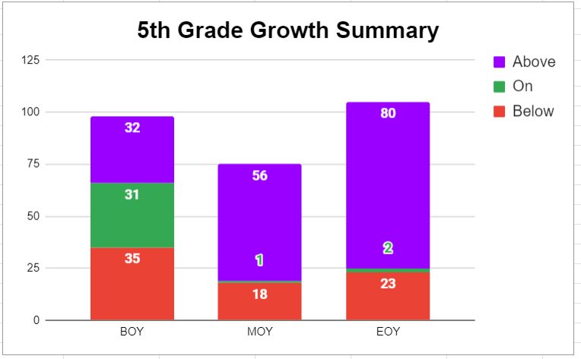

EOY yearly comparisons | Below | On | Above
2022-2023 | 22 | 2 | 76
2021-2022 | 32 | 1 | 67
2020-2021 | 16 | 6 | 78

Summary of Data: Grade 5 students demonstrated growth from the BOY to the EOY. The percentage of grade 5 students meeting the benchmark was greater than last year with 78% meeting or exceeding the EOY benchmark.

Phonemic Awareness Reading Progression 2022-2023
(# of Students)
 | K | 1 | 2 | 3
Basic Alphabet Knowledge | 6 | 0 | 0 | 0
Using Letter Sounds | 14 | 0 | 0 | 0
Using Letter Patterns | 19 | 6 | 0 | 0
Blends and Digraphs | 35 | 4 | 4 | 0
Vowel Consonant -e | 12 | 19 | 2 | 0
R-Controlled Vowels | 8 | 13 | 7 | 3
Vowel Teams | 6 | 13 | 1 | 7
Lower Text Complexity | 0 | 8 | 7 | 18
Higher Text Complexity | 1 | 20 | 17 | 1
Students Read Silently | 0 | 20 | 45 | 49

 | K | 1st | 2nd | 3rd
% Below | 39 | 53 | 46 | 39
% At/Exceeds | 61 | 47 | 54 | 61
Summary:
Grade 2 had a significant increase in the percentage of students meeting their phonics benchmarks compared to last school year. All other grades had slightly less averages of students meeting their benchmarks compared to last year. Grade K & grade 1 phonics data aligns to their NSGRA data. Grade 2 students are stronger in comprehension than phonics while grade 3 is much stronger in phonics than comprehension.

Phonemic Awareness Reading Progression 2021-2022
(# of Students)
 | K | 1 | 2 | 3
Basic Alphabet Knowledge | 4 | 0 | 1 | 0
Using Letter Sounds | 14 | 0 | 3 | 0
Using Letter Patterns | 23 | 4 | 0 | 1
Blends and Digraphs | 32 | 11 | 4 | 5
Vowel Consonant -e | 13 | 5 | 8 | 0
R-Controlled Vowels | 15 | 9 | 7 | 2
Vowel Teams | 1 | 16 | 2 | 6
Lower Text Complexity | 0 | 3 | 16 | 21
Higher Text Complexity | 5 | 27 | 20 | 0
Students Read Silently | 0 | 15 | 33 | 64

 | K | 1st | 2nd | 3rd
% Below | 38 | 50 | 65 | 35
% At/Exceeds | 62 | 50 | 35 | 65
Summary: Grades k-1 have increased the percentage of students at or above EOY goals. Grade 2 data is comparable to last year’s second grade data and the data for those students leaving grade 1. Grade 3 data is comparable to last year’s third grade data but also demonstrates a significant number of students at or above the benchmark when compared to the percentage of those students meeting the benchmark at the end of their second-grade year.

Access Testing Data
% overall at each proficiency level 2022-2023
 | K | 1 | 2 | 3 | 4 | 5
Level 1Entering | 33 | 13 | 0 | 0 | 8 | 0
Level 2 Emerging | 25 | 13 | 40 | 40 | 0 | 0
Level 3 Developing | 33 | 50 | 60 | 60 | 31 | 25
Level 4 Expanding | 8 | 13 | 0 | 0 | 54 | 50
Level 5 Bridging | 0 | 13 | 0 | 0 | 8 | 25
Level 6 Reaching | 0 | 0 | 0 | 0 | 0 | 0
# of students exiting | 0 | 1 | 0 | 0 | 3 | 1
A total of forty-seven students took the ACCESS test in 2023. Three students had a clear exit (scored 5 or higher) and we reclassified two students. We were able to compare the scores for thirty-four students. Thirty or 88% of students increased their score.

Access Testing Data
% overall at each proficiency level 2021-2022

 | K | 1 | 2 | 3 | 4 | 5
Level 1 Entering | 29 | 0 | 17 | 0 | 0 | 25
Level 2 Emerging | 29 | 83 | 17 | 36 | 25 | 0
Level 3 Developing | 29 | 17 | 50 | 64 | 25 | 25
Level 4 Expanding | 14 | 0 | 17 | 0 | 50 | 50
Level 5 Bridging | 0 | 0 | 0 | 0 | 0 | 0
Level 6 Reaching | 0 | 0 | 0 | 0 | 0 | 0
# of students exiting | 0 | 0 | 1 | 0 | 0 | 1
A total of thirty-eight students took the ACCESS test in 2022. Two students exited the program. We were able to compare the scores for twenty-nine students. Twenty-four or 83% of students increased their score or remained the same.
IOWA Test EOY 2022-2023 National Percentile Ranks
ELA Total
 | 1-24 | 25-49 | 50-74 | 75-99 | Overall
Grade K | 36 | 25 | 23 | 15 | 38
Grade 1 | 34 | 33 | 15 | 18 | 39
Grade 2 | 35 | 18 | 29 | 17 | 44
Grade 3 | 38 | 33 | 15 | 14 | 37
Grade 4 | 40 | 27 | 19 | 14 | 38
Grade 5 | 22 | 27 | 22 | 28 | 52
SummAll grades met their Smart goal of a at least 3% increase in NPR from BOY- EOY. Grade 1 students demonstrated significant increases since the BOY. Grades 2, 3&5 had a much higher average NPR score than last year.

IOWA Test Spring 2021-2022 National Percentile Ranks
ELA Total
 | 1-24 | 25-49 | 50-74 | 75-99 | Overall
Grade K | 35 | 31 | 21 | 12 | 36
Grade 1 | 32 | 19 | 23 | 26 | 46
Grade 2 | 46 | 20 | 22 | 11 | 33
Grade 3 | 45 | 33 | 17 | 5 | 29
Grade 4 | 28 | 24 | 31 | 17 | 45
Grade 5 | 34 | 26 | 26 | 14 | 40
Grade 1 students increased their NPR compared to last year. Current grade 2 students ranked higher than the previous year’s students. Grade 3 students continue to perform below the average range. This year 78 % of current grade 3 students ranked below an NPR of 50 when compared to 59% of those same students last year as second graders.

IOWA Test MOY 2022-2023 National Percentile Ranks
Math Total
 | 1-24 | 25-49 | 50-74 | 75-99 | Overall
Grade K | 49 | 22 | 20 | 8 | 27
Grade 1 | 40 | 20 | 23 | 17 | 37
Grade 2 | 30 | 28 | 20 | 22 | 45
Grade 3 | 43 | 24 | 27 | 6 | 31
Grade 4 | 51 | 27 | 13 | 8 | 28
Grade 5 | 29 | 34 | 24 | 13 | 39
Summary:
All grades met their Smart goal of at least 3% increase in NPR from BOY- EOY. Grades 2 &5 demonstrated substantial increases since BOY.

IOWA Test Spring 2021-2022 National Percentile Ranks
Math Total
 | 1-24 | 25-49 | 50-74 | 75-99 | Overall
Grade K | 25 | 44 | 21 | 10 | 39
Grade 1 | 33 | 29 | 15 | 23 | 42
Grade 2 | 59 | 26 | 10 | 4 | 23
Grade 3 | 60 | 26 | 13 | 1 | 22
Grade 4 | 27 | 47 | 15 | 11 | 36
Grade 5 | 47 | 29 | 20 | 5 | 29
Summary: Grades 1 & 2 show significant increases in NPR for math compared to last year. Grade 3 students had an average NPR much lower than previous grade 3 students but comparable to their rankings in the previous grade. Math NPR for grades 4 & 5 were lower than last year.

21-22 Spring CogAT
Age Percentile Rank
Data Summary:
*BOTH Kindergarten and Grade 2 students only took Cogat in the fall this school year (22-23). Comparison to previous years are invalid due to the time of the testing window.

Both Grade K and grade 2 students demonstrate strengths in quantitative reasoning.

 | Grade K  FALL | Grade2  *SPRING
Verbal | 27 (Fall 21) | 40
Quantitative | 37 (Fall 21) | 84
Nonverbal | 27 (Fall 21) | 69
Composite (VQ) | 29 (Fall 21) | 65
Composite (VN) | 23 (Fall 21) | 55
Composite (QN) | 31 (Fall 21) | 77
Composite (VQN) | 27 (Fall 21) | 67

22-23 FALL CogAT
Age Percentile Rank
 | Grade K FALL | Grade  *2 FALL
Verbal | 23 | 35
Quantitative | 32 | 39
Nonverbal | 24 | 36
Composite (VQ) | 25 | 35
Composite (VN) | 20 | 34
Composite (QN) | 27 | 35
Composite (VQN) | 23 | 34
Summary Statement:
Both groups scored highest in Quantitative skills.

Georgia Milestones Data Summary
**2020 GMAS data unavailable.
Percentage of Students by Achievement Level-English Language Arts GMAS
Levels | 3rd Grade |  |  | 4th Grade |  |  | 5th Grade
 | 2021 | 2022 | 2023 | 2021 | 2022 | 2023 | 2021 | 2022 | 2023
Level 4-Distinguished | 3 | 2 | 5 | 4 | 5 | 7 | 1 | 2 | 3
Level 3-Proficient | 20 | 16 | 19 | 27 | 30 | 14 | 34 | 32 | 42
Level 2-Developing | 37 | 27 | 23 | 43 | 39 | 37 | 42 | 43 | 33
Level 1-Beginning | 40 | 55 | 54 | 27 | 27 | 42 | 23 | 23 | 22
Summary of Data: Summary of Data: Grade 3 had significantly less students meeting proficiency than last year. Grade 4 has increased the percentage of students meeting proficiency over the past two years. *Due to school closure for Covid-19, the 2019-2020 GMAS was not administered.

Percentage of Students by Achievement Level-Mathematics GMAS
Levels | 3rd Grade |  |  | 4th Grade |  |  | 5th Grade
 | 2021 | 2022 | 2023 | 2021 | 2022 | 2023 | 2021 | 2022 | 2023
Level 4-Distinguished | 0 | 0 | 3 | 2 | 5 | 2 | 1 | 5 | 6
Level 3-Proficient | 8 | 12 | 24 | 25 | 34 | 23 | 34 | 23 | 19
Level 2-Developing | 55 | 46 | 39 | 46 | 38 | 44 | 42 | 27 | 48
Level 1-Beginning | 38 | 43 | 35 | 27 | 24 | 32 | 23 | 44 | 27
Summary of Data: Grade 4 showed gains in proficiency levels. Grades 3 had an increase in proficient but a shift from level 2 developing to level 1 beginning. Grade 5 students decreased the average number at proficient and increased the average of students at level 1.
Due to school closure for Covid-19, the 2019-2020 GMAS was not administered.
*GMAS data for 2021-2022 unavailable at this time.

Percentage of 5th Grade Students by Achievement Level-Science GMAS
Levels | 5th Grade
 | 2021 | 2022 | 2023
Level 4-Distinguished | 3 | 1 | 33
Level 3-Proficient | 34 | 26 | 37
Level 2-Developing | 34 | 35 | 25
Level 1-Beginning | 29 | 37 | 5
Summary of Data: Grade 5 had a decrease in the percentage of students meeting proficiency. Classroom assessment rigor needs to be analyzed in light of GMAS data. The average final grade of all 5th grade students was 95 yet only 26% achieved proficient or distinguished.
Due to school closure for Covid-19, the 2019-2020 GMAS was not administered.

Percentage of Students In Mastery Category-English Language Arts GMAS 2022
 | Third Grade |  | Fourth Grade |  | Fifth Grade
 | Reading/  Vocabulary | Writing/  Language | Reading/  Vocabulary | Writing/  Language | Reading/  Vocabulary | Writing/  Language
Remediate learning | 78 | 82 | 61 | 58 | 66 | 56
Monitor Learning | 15 | 12 | 21 | 33 | 25 | 21
Accelerate Learning | 7 | 6 | 18 | 9 | 9 | 23
Summary of Data: A higher percentage of students in grade 3 were in the remediate learning category than last year while 82% of third graders need remediation in writing.

Domain Performance (percentage of students) Mathematics 2022-2023 GMAS
Domains | 3rd Grade |  |  | 4th Grade |  |  | 5th Grade
 | 1 | 2 | 3 | 1 | 2 | 3 | 1 | 2 | 3
Operations/Algebraic Thinking | 64 | 28 | 9 | 64 | 30 | 6 | 59 | 21 | 20
Number and Operations | 71 | 18 | 11 | 53 | 33 | 15 | -- | -- | --
Numbers/Operations in Base 10 | -- | -- | -- | -- | -- | -- | 65 | 20 | 15
Numbers/Operations in Fractions | -- | -- | -- | -- | -- | -- | 73 | 21 | 7
Measurement and Data | 71 | 21 | 8 | 41 | 22 | 5 | 68 | 19 | 13
Geometry | 49 | 39 | 13 | 85 | 13 | 3 | 65 | 35 | 0
Summary of Data: The percentage of students proficient in operations and algebraic thinking increased from grade 3-grade 5. Numbers and operations in Fractions continues to be a deficit for our students.

Domain Performance (percentage of students) Mathematics 2021-2022 GMAS
Domains | 3rd Grade |  |  | 4th Grade |  |  | 5th Grade
 | 1 | 2 | 3 | 1 | 2 | 3 | 1 | 2 | 3
Operations/Algebraic Thinking | 77 | 20 | 3 | 57 | 33 | 10 | 46 | 53 | 1
Number and Operations | 83 | 15 | 2 | * | * | * | * | * | *
Numbers/Operations in Base 10 | * | * | * | 45 | 31 | 25 | 59 | 31 | 10
Numbers/Operations in Fractions | * | * | * | 58 | 27 | 15 | 73 | 18 | 10
Measurement and Data | 85 | 13 | 2 | 64 | 28 | 8 | 62 | 29 | 10
Geometry | 52 | 40 | 8 | 57 | 27 | 16 | 74 | 23 | 3
Summary of Data: *Test strand does not apply. Grade 3 students increased the percentage of students at levels 2+ in all domains except measurement and data compared to last year. Grades 4 and 5 also demonstrated increased percentages of level 2-3 students. *

Domain Performance Science 2022- 2023 GMAS
(percentage of students)
Domains | 5th Grade
 | 1 | 2 | 3
Earth Science | 73 | 19 | 8
Physical Science | 59 | 24 | 17
Life Science | 64 | 23 | 13
Summary of Data: Students in grad 5 had the least percent of students proficient in the area of Earth science. OHE students out performed the district average in all science domains. Physical science had the highest proficiency.

Domain Performance Science 2021- 2022 GMAS
(percentage of students)
Domains | 5th Grade
 | 1 | 2 | 3
Earth Science | 63 | 32 | 5
Physical Science | 56 | 31 | 13
Life Science | 69 | 20 | 11
Summary of Data: There was a decrease in the percentage of students at levels 2-3 in all areas particularly in the domain of life science.

Student Demographics 2021-2022 GMAS-Reading
 | Third Grade |  |  |  | Fourth Grade |  |  |  | Fifth Grade
 | 1 | 2 | 3 | 4 | 1 | 2 | 3 | 4 | 1 | 2 | 3 | 4
All | 55 | 27 | 16 | 2 | 27 | 39 | 30 | 5 | 23 | 43 | 32 | 2
Special Education | 68 | 27 | 5 | 0 | 69 | 13 | 19 | 0 | 47 | 47 | 6 | 0
Female | 56 | 27 | 16 | 2 | 22 | 41 | 31 | 4 | 11 | 53 | 34 | 3
Male | 55 | 28 | 15 | 2 | 31 | 37 | 29 | 4 | 32 | 36 | 30 | 2
Black | 65 | 24 | 6 | 4 | 28 | 34 | 34 | 4 | 30 | 43 | 26 | 0
Hispanic | 71 | 18 | 12 | 0 | 18 | 47 | 35 | 0 | 7 | 60 | 27 | 7
White | 41 | 26 | 33 | 0 | 21 | 46 | 21 | 13 | 13 | 38 | 44 | 6
Summary of Data: Less students in special education met proficiency compared to all students while a higher percentage of grade 5 students in special education achieved at level 2. Grades 3 and 5 have a significantly higher percentage of white students at levels 3-4 than other subgroups.

Student Demographics 2021-2022 GMAS-Math
 | Third Grade |  |  |  | Fourth Grade |  |  |  | Fifth Grade
 | 1 | 2 | 3 | 4 | 1 | 2 | 3 | 4 | 1 | 2 | 3 | 4
All | 43 | 46 | 12 | 0 | 24 | 38 | 34 | 5 | 44 | 27 | 23 | 5
Special Education | 59 | 36 | 5 | 0 | 56 | 31 | 6 | 4 | 71 | 24 | 6 | 6
Female | 50 | 40 | 10 | 0 | 22 | 41 | 33 | 4 | 39 | 34 | 24 | 3
Male | 36 | 51 | 13 | 0 | 25 | 35 | 35 | 6 | 47 | 23 | 23 | 8
Black | 49 | 45 | 6 | 0 | 26 | 36 | 32 | 6 | 58 | 26 | 15 | 0
Hispanic | 41 | 41 | 18 | 0 | 29 | 29 | 35 | 6 | 27 | 27 | 40 | 7
White | 37 | 52 | 11 | 0 | 13 | 46 | 38 | 4 | 25 | 25 | 25 | 25
Summary of Data: Grades 3 &4 had a higher percentage of students meeting proficiency than last year, but more students moved from level 2 to level 1. Grade 5 had a significantly higher percentage of students at level 1 compared to last year.

Student Demographics 2021-2022 GMAS-Science
 | Fifth Grade
 | 1 | 2 | 3 | 4
All | 37 | 35 | 26 | 1
Special Education | 59 | 35 | 6 | 6
Female | 37 | 26 | 34 | 3
Male | 38 | 42 | 21 | 0
Black | 53 | 26 | 21 | 0
Hispanic | 20 | 47 | 27 | 7
White | 19 | 38 | 44 | 0
Summary of Data: There was a higher percentage of all students at level 1 with significantly more students in special education at level 1 compared to last year. While data for most subgroups indicate a decrease in achievement level, white students increased the percentage of students at levels 2 and higher.

Elementary School Staff Profile

 | 2020-2021 | 2021-2022 | 2022-2023
Number of Certified Staff (teachers) | 46 | 45 | 46
Number of Certified w/ Advanced Degrees | 30 | 27 | 26
Average Number of Years’ Experience | 13 | 13 | 13
% of Staff Professionally Qualified | 100 | 100 | 100
Number of Teachers at OHE for 3 or more years | 33 | 36 | 37
Number of Teachers at OHE for less than 3 years | 13 | 9 | 9
Number of Classified Staff (paraprofessionals) | 21 | 21 | 23
(Include 1-3 sentences highlighting the overall major findings.)
Fifty-seven percent of our staff population hold advanced degrees, and the staff at Oak Hill Elementary School is 100% highly qualified. We have 70% of our teachers who have been at Oak Hill 3 or more years.

Number of Teachers at TKES Level on Summative Assessment | 2020-2021 | 2021-2022 | 2022-2023
Level 1 | 0 | 0 | 0
Level 2 | 0 | 0 | 0
Level 3 | 46 | 45 | 46
(Include 1-3 sentences highlighting the overall major findings.)
All teachers were consistent in implementation of the TKES standards and scored at level 3.

2022-2023 Discipline Incident System Summary
Category | # of Referrals | Total Students
Alcohol | 0 | 0
Arson | 0 | 0
Battery | 0 | 0
Bullying | 2 | 1
Breaking & Entering/Robbery/Larceny/Thief | 0 | 0
Computer Trespass | 0 | 0
Disorderly Conduct | 0 | 0
Drugs Except Alcohol and Tobacco | 0 | 0
Fighting | 2 | 2
Inappropriate School Behavior | 0 | 0
Inappropriate Striking/Touching/Kicking -10 | 0 | 0
Indecent Exposure | 0 | 0
Obscenity | 0 | 0
Reckless/Disorderly Conduct | 0 | 0
Sexual Harassment | 0 | 0
Sexual Battery | 0 | 0
Sex Offenses | 0 | 0
Theft/Possession of Stolen Objects | 0 | 0
Threatening/Intimidating Students | 2 | 2
Threatening/Endangering School Employee | 0 | 0
Unauthorized Area/Trespassing | 0 | 0
Vandalism | 0 | 0
Weapon/Knife | 0 | 0
23 Weapon/other | 1 | 1
Weapon/ Gun | 0 | 0
24 Other | 3 | 3
Other (banned item) | 1 | 1
Gang related | 0 | 0
Other-Student Incivility | 26 | 21
Other-Possession of Unapproved Items | 0 | 0
Other-Attendance Related | 0 | 0
Total | 36 | 26
Summary of Discipline Data: The number of discipline referrals is slightly less than last year. We had 2 incidents of fighting and one weapon (other) incident. Referrals for student incivility made up 76% of referrals.
2021-2022 Discipline Incident System Summary
Category | Number of Referrals | Total Students
Alcohol | 0 | 0
Arson | 0 | 0
Battery | 0 | 0
Bullying | 2 | 1
Breaking & Entering/Robbery/Larceny/Thief | 0 | 0
Computer Trespass | 0 | 0
Disorderly Conduct | 4 | 4
Drugs Except Alcohol and Tobacco | 0 | 0
Fighting | 6 | 5
Inappropriate School Behavior | 0 | 0
Inappropriate Striking/Touching/Kicking -10 | 0 | 0
Indecent Exposure | 0 | 0
Obscenity | 0 | 0
Reckless/Disorderly Conduct | 0 | 0
Sexual Harassment | 0 | 0
Sexual Battery | 0 | 0
Sex Offenses | 0 | 0
Theft/Possession of Stolen Objects | 1 | 1
Threatening/Intimidating Students | 1 | 1
Threatening/Endangering School Employee | 0 | 0
Unauthorized Area/Trespassing | 0 | 0
Vandalism | 1 | 1
Weapon/Knife | 1 | 1
Weapon/ Gun | 0 | 0
Other (banned item) | 5 | 5
Gang related | 0 | 0
Other-Student Incivility | 25 | 19
Other-Possession of Unapproved Items | 0 | 0
Other-Attendance Related | 2 | 2
Total | 48 | 32
Summary of Discipline Data: The number of discipline referrals is significantly higher than the previous two years during the pandemic. However, the number of incidents is a third less than those reported in 2019-2020 prior to Covid. We had 6 incidents of fighting. Over half of the referrals were for student incivility. Due to coding and reporting contradiction concerns, we will also analyze the “Behavior Event” report from Infinite Campus.
Discipline Data Action System Summary 2022-2023
Number of students

Action Taken | Hisp | Am Ind | Asian | Black | Pac  Island | White | Mult-Racial | #  Male | #  Female | #  ELL | #  SWD | Total # Actions | #  days | Total # Students
Detention | 0 | 0 | 0 | 0 | 0 | 0 | 0 | 0 | 0 | 0 | 0 | 0 | 0 | 0
Corporal Punishment | 0 | 0 | 0 | 0 | 0 | 0 | 0 | 0 | 0 | 0 | 0 | 0 | 0 | 0
In-School suspension | 0 | 0 | 0 | 0 | 0 | 0 | 0 | 0 | 0 | 0 | 0 | 0 | 0 | 0
Out of School Suspension | 4 | 0 | 0 | 15 | 0 | 2 | 0 | 12 | 9 | 1 | 8 | 26 | 52 | 21
Expulsion | 0 | 0 | 0 | 0 | 0 | 0 | 0 | 0 | 0 | 0 | 0 | 0 | 0 | 0
Suspended from Riding the Bus | 1 | 0 | 0 | 6 | 0 | 0 | 1 | 4 | 4 | 0 | 4 | 9 | 0 | 8
Alternative School | 0 | 0 | 0 | 0 | 0 | 0 | 0 | 0 | 0 | 0 | 0 | 0 | 0 | 0
Court or Juvenile System Referral | 0 | 0 | 0 | 0 | 0 | 0 | 0 | 0 | 0 | 0 | 0 | 0 | 0 | 0
Other Discipline Action | 0 | 0 | 0 | 1 | 0 | 0 | 1 | 1 | 1 | 0 | 1 | 2 | 0 | 2
Removal from Class at Teacher’s request | 0 | 0 | 0 | 0 | 0 | 0 | 0 | 0 | 0 | 0 | 0 | 0 | 0 | 0
Physical Restraint | 0 | 0 | 0 | 0 | 0 | 0 | 0 | 0 | 0 | 0 | 0 | 0 | 0 | 0
Total | 5 | 0 | 0 | 18 | 0 | 2 | 1 | 14 | 12 | 1 | 11 | 36 | 0 | 26
Summary Statement:
There were few discipline actions this year. The majority of actions resulted in suspension outside of school. These instances were experienced almost equally by gender. Approximately 42% of instances involved students with disabilities, 69% involved black students, 19% involved Hispanic students, and 8% involved white students.

Discipline Data Action System Summary
2021-2022 Number of students

Action Taken | Hisp | Am Ind | Asian | Black | Pac  Island | White | Mult-Racial | #  Male | #  Female | #  ELL | #  SWD | Total # Actions | Total # Students
Detention | 0 | 0 | 0 | 0 | 0 | 0 | 0 | 0 | 0 | 0 | 0 | 0 | 0
Corporal Punishment | 0 | 0 | 0 | 0 | 0 | 0 | 0 | 0 | 0 | 0 | 0 | 0 | 0
In-School suspension | 0 | 0 | 0 | 0 | 0 | 0 | 0 | 0 | 0 | 0 | 0 | 0 | 0
Out of School Suspension | 3 | 0 | 0 | 19 | 0 | 6 | 2 | 24 | 6 | 2 | 15 | 40 | 30
Expulsion | 0 | 0 | 0 | 0 | 0 | 0 | 0 | 0 | 0 | 0 | 0 | 0 | 0
Suspended from Riding the Bus | 1 | 0 | 0 | 2 | 0 | 0 | 1 | 4 | 0 | 0 | 2 | 4 | 4
Alternative School | 0 | 0 | 0 | 0 | 0 | 0 | 0 | 0 | 0 | 0 | 0 | 0 | 0
Court or Juvenile System Referral | 0 | 0 | 0 | 0 | 0 | 0 | 0 | 0 | 0 | 0 | 0 | 0 | 0
Other Discipline Action | 0 | 0 | 0 | 3 | 0 | 1 | 1 | 3 | 2 | 0 | 0 | 5 | 5
Removal from Class at Teacher’s request | 0 | 0 | 0 | 0 | 0 | 0 | 0 | 0 | 0 | 0 | 0 | 0 | 0
Physical Restraint | 0 | 0 | 0 | 0 | 0 | 0 | 0 | 0 | 0 | 0 | 0 | 0 | 0
Total | 3 | 0 | 0 | 19 | 0 | 6 | 4 | 25 | 7 | 2 | 16 | 48 | 32
The number of referrals: The number of students suspended outside of school was disproportionately higher for males than females and black students. The number of suspensions for students with disabilities is significantly higher than all other subgroups.

School Discipline Summary (Infinite Campus)

 | 2019-2020 | 2020-2021 | 2021-2022 | 2022-2023
# of Referrals – School | 71 | 20 | 106 | 86
# of Referrals - Bus | 7 | 8 | 7 | 5
Total no. of Referrals | 78 | 28 | 111 | 91

2022 2023 Behavior Event Summary
(Infinite Campus)

Action Taken | Hisp | Am Ind | Asian | Black | Pac  Island | White | Mult-Racial | #  Male | #  Female | #  SWD | Total # Actions | Total # Students
Banned Item | 0 | 0 | 0 | 1 | 0 | 0 | 0 | 0 | 1 | 0 | 1 | 1
BULLYING | 1 | 0 | 0 | 0 | 0 | 0 | 0 | 1 | 0 | 1 | 2 | 1
Cam/Cl Dist | 2 | 0 | 0 | 9 | 0 | 1 | 0 | 7 | 4 | 8 | 0 | 11
Disob/Disre | 1 | 0 | 0 | 6 | 0 | 1 | 2 | 5 | 5 | 6 | 12 | 10
Failure to Report Medication | 0 | 0 | 0 | 0 | 0 | 0 | 0 | 0 | 0 | 0 | 0 | 0
FIGHTING | 0 | 0 | 0 | 1 | 0 | 0 | 1 | 1 | 1 | 1 | 2 | 2
striking/touch/kick | 3 | 0 | 0 | 5 | 0 | 0 | 2 | 6 | 4 | 6 | 13 | 10
Inapp Sch Behavior | 4 | 0 | 0 | 14 | 0 | 4 | 2 | 24 | 6 | 8 | 30 | 24
LvCmpsNoPerm | 0 | 0 | 0 | 0 | 0 | 0 | 0 | 0 | 0 | 0 | 0 | 0
Misbhvr/Bus | 2 | 0 | 0 | 8 | 0 | 1 | 1 | 6 | 6 | 5 | 14 | 12
Obscenity | 1 | 0 | 0 | 0 | 0 | 0 | 0 | 1 | 0 | 0 | 1 | 1
RECK/DIS/CON | 0 | 0 | 0 | 0 | 0 | 0 | 0 | 0 | 0 | 0 | 0 | 0
THF / POS STOLN | 0 | 0 | 0 | 0 | 0 | 0 | 0 | 0 | 0 | 0 | 0 | 0
THR / INTIM STU | 1 | 0 | 0 | 1 | 0 | 0 | 0 | 2 | 0 | 1 | 2 | 2
Threatening/Endangering Sch Employee | 0 | 0 | 0 | 0 | 0 | 0 | 0 | 0 | 0 | 0 | 0 | 0
VANDALISM | 0 | 0 | 0 | 0 | 0 | 0 | 0 | 0 | 0 | 0 | 0 | 0
WPN / DSTR DEV | 0 | 0 | 0 | 1 | 0 | 0 | 0 | 1 | 0 | 0 | 1 | 1
Total | 15 | 0 | 0 | 46 | 0 | 7 | 8 | 54 | 27 | 31 | 78 | 75
Summary: The number of incidents reported was less than last year. Males were referred more often than females. Most referrals were for inappropriate school behavior or classroom disturbance.

2021 2022 Behavior Event Summary
(Infinite Campus)
Action Taken | Hisp | Am Ind | Asian | Black | Pac  Island | White | Mult-Racial | #  Male | #  Female | #  ELL | #  SWD | Total # Actions | Total # Students
Banned Item | 0 | 0 | 0 | 0 | 0 | 2 | 0 | 2 | 0 | 0 | 0 | 2 | 2
BULLYING | 0 | 0 | 0 | 2 | 0 | 0 | 0 | 2 | 0 | 0 | 0 | 2 | 1
Cam/Cl Dist | 0 | 0 | 0 | 15 | 0 | 3 | 0 | 15 | 3 | 0 | 11 | 18 | 10
Disob/Disre | 4 | 0 | 0 | 19 | 0 | 3 | 0 | 14 | 12 | 3 | 11 | 26 | 15
Failure to Report Medication | 0 | 0 | 0 | 2 | 0 | 0 | 0 | 2 | 0 | 0 | 2 | 2 | 2
FIGHTING | 1 | 0 | 0 | 5 | 0 | 0 | 0 | 2 | 4 | 1 | 1 | 6 | 5
striking/touch/kick | 0 | 0 | 0 | 8 | 0 | 1 | 1 | 7 | 3 | 0 | 4 | 10 | 9
Inapp Sch Behavior | 4 | 1 | 0 | 18 | 0 | 3 | 3 | 25 | 4 | 1 | 15 | 29 | 22
LvCmpsNoPerm | 0 | 0 | 0 | 1 | 0 | 0 | 0 | 1 | 0 | 0 | 0 | 1 | 1
Misbhvr/Bus | 2 | 0 | 0 | 2 | 0 | 2 | 2 | 7 | 1 | 0 | 4 | 8 | 6
RECK/DIS/CON | 0 | 0 | 0 | 2 | 0 | 2 | 0 | 4 | 0 | 0 | 3 | 4 | 4
THF / POS STOLN | 0 | 0 | 0 | 0 | 0 | 0 | 1 | 0 | 1 | 0 | 0 | 1 | 1
THR / INTIM STU | 0 | 0 | 0 | 0 | 0 | 1 | 0 | 1 | 0 | 0 | 0 | 1 | 1
Threatening/Endangering Sch Employee | 0 | 0 | 0 | 1 | 0 | 0 | 0 | 1 | 0 | 0 | 0 | 1 | 1
VANDALISM | 0 | 0 | 0 | 1 | 0 | 0 | 0 | 1 | 0 | 0 | 0 | 1 | 1
WPN / KNIFE | 0 | 0 | 0 | 1 | 0 | 0 | 0 | 1 | 0 | 0 | 0 | 1 | 1
Total | 11 | 1 | 0 | 77 | 0 | 17 | 7 | 85 | 28 | 5 | 51 | 113 | 82
The number of behavior events referred were significantly higher for males than females.

Student Attendance Summary
Number of Students Absent

 | 2020-2021 | 2021-2022 | 2022-2023
Total Students |  | 702 | 712
Total number of students absent 5 or less days | 321 | 234 | 227
Total number of students absent 5 or more days | 349 | 468 | 485
% of students absent 5 or less days | 47.91 | 33.33 | 31.88
% of students absent 5 or more days | 52.09 | 66.67 | 68.12
Summary of Attendance Data: This school year we had a higher average of students absent 5 or more days than the past two years and 41% of students had 10 or more absences. Lack of attendance and excessive tardiness leads to missed instruction particularly during intervention time. This data does not include numerous late arrivals (some frequently 30 min. to an hour late) or early checkouts.

School Attendance Data 2022-2023

Subgroups | Total  # Students | Number and Percent of Absences
 |  | %  Percent of students absent for 5 days or less | %  Percent of students absent 6-10 days | %  Percent of students absent 11-15 days absent | %  Percent of students absent >15 days absent
Total enrollment | 712 | 32 | 27 | 21 | 20
American Indian/Alaskan | 4 | 50 | 25 | 0 | 25
Pacific Islander | 0 | 0 | 0 | 0 | 0
Asian | 1 | 0 | 0 | 0 | 100
Black | 383 | 32 | 28 | 22 | 18
Hispanic | 106 | 26 | 29 | 18 | 26
Multi-Racial | 52 | 35 | 31 | 23 | 12
White | 166 | 35 | 22 | 20 | 23
English Learners | 49 | 25 | 24 | 20 | 30
Students With Disability | 143 | 27 | 25 | 28 | 20
We had 68% of our students missed 6 or more days and 41% of students had 10 or more absences. This data does not include tardies or checkouts.
School Attendance Data 2021-2022

Subgroups | Total  # Students | Number and Percent of Absences
 |  | <  Absent for 5 days or less | %  Percent of students absent for 5 days or less | >  More than 5 days absent | %  Percent of students absent for more than 5 days
Total enrollment | 702 | 234 | 33.33 | 468 | 66.67
American Indian/Alaskan | 4 | 0 | 0 | 4 | 100
Pacific Islander | 0 | 0 | 0 | 0 | 0
Asian | 1 | 1 | 100 | 0 | 0
Black | 369 | 130 | 35.23 | 239 | 64.77
Hispanic | 92 | 24 | 26.09 | 68 | 73.91
Multi-Racial | 54 | 14 | 25.93 | 40 | 74.07
White | 182 | 65 | 35.71 | 117 | 64.29
English Learners | 40 | 12 | 30 | 28 | 70
Students With Disability | 127 | 40 | 31.50 | 87 | 68.50
Summary of Attendance Data: This school year we had a higher average of all students absent 5 or more days than the past two years. All four students from the American Indian/Alaskan subgroup were absent greater than five days. The highest percentages of students absent greater than 5 days were from the subgroups Hispanic and Multi-Racial.

FY23 Oak Hill Milestones Sub-Group Performance
ELA

3rd Grade English Language Arts
Percentage of Students Scoring in Each Achievement Level
Group | Mean Scale Score | Beginning Learner  (290-474) | Developing Learner  (475-524) | Proficient Learner  (525-579) | Distinguished Learner  (580-705) | Proficient  (Levels 3&4)
All Students | 477 | 54% | 23% | 19% | 5% | 24%
Female | 486 | 45% | 26% | 21% | 8% | 29%
Male | 468 | 62% | 19% | 17% | 2% | 19%
Asian/Pacific Islander | - | - | - | - | - | -
Black, Non-Hispanic | 471 | 59% | 24% | 8% | 8% | 16%
Hispanic | 453 | 64% | 27% | 9% | 0% | 9%
White, Non-Hispanic | 500 | 38% | 15% | 46% | 0% | 46%
Multiracial | 509 | 29% | 14% | 57% | 0% | 57%
4th Grade English Language Arts
Percentage of Students Scoring in Each Achievement Level
Group | Mean Scale Score | Beginning Learner  (290-474) | Developing Learner  (475-524) | Proficient Learner  (525-579) | Distinguished Learner  (580-705) | Proficient  (Levels 3&4)
All Students | 491 | 42% | 37% | 14% | 7% | 21%
Female | 497 | 35% | 42% | 18% | 5% | 23%
Male | 485 | 49% | 32% | 9% | 9% | 18%
Asian/Pacific Islander | - | - | - | - | - | -
Black, Non-Hispanic | 487 | 46% | 36% | 13% | 5% | 18%
Hispanic | 485 | 45% | 40% | 10% | 5% | 15%
White, Non-Hispanic | 503 | 30% | 41% | 15% | 15% | 30%
Multiracial | 495 | 43% | 29% | 29% | 0% | 29%

5th Grade English Language Arts
Percentage of Students Scoring in Each Achievement Level
Group | Mean Scale Score | Beginning Learner  (290-474) | Developing Learner  (475-524) | Proficient Learner  (525-579) | Distinguished Learner  (580-705) | Proficient  (Levels 3&4)
All Students | 514 | 22% | 33% | 42% | 3% | 45%
Female | 521 | 14% | 37% | 47% | 2% | 49%
Male | 508 | 29% | 29% | 38% | 4% | 42%
Asian/Pacific Islander | - | - | - | - | - | -
Black, Non-Hispanic | 515 | 24% | 31% | 41% | 3% | 44%
Hispanic | 512 | 18% | 47% | 35% | 0% | 35%
White, Non-Hispanic | 521 | 16% | 24% | 56% | 4% | 60%
Multiracial | 496 | 25% | 50% | 25% | 0% | 25%
Summary of Data: Significantly, more males perform at level 1 than females. In grade 3 black student perform at higher proficiency levels but in grade 5 white students perform at higher levels. Grade 5 students had higher percentages of students at proficiency in all subgroups.

Math
3rd Grade Mathematics
Percentage of Students Scoring in Each Achievement Level
Group | Mean Scale Score | Beginning Learner  (290-474) | Developing Learner  (475-524) | Proficient Learner  (525-579) | Distinguished Learner  (580-705) | Proficient  (Levels 3&4)
All Students | 498 | 35% | 39% | 24% | 3% | 27%
Female | 497 | 34% | 42% | 21% | 3% | 24%
Male | 499 | 36% | 36% | 26% | 2% | 28%
Asian/Pacific Islander |  | - | - | - | - | -
Black, Non-Hispanic | 491 | 41% | 37% | 22% | 0% | 22%
Hispanic | 481 | 45% | 36% | 18% | 0% | 18%
White, Non-Hispanic | 512 | 23% | 46% | 23% | 8% | 31%
Multiracial | 544 | 0% | 43% | 43% | 14% | 57%
4th Grade Mathematics
Percentage of Students Scoring in Each Achievement Level
Group | Mean Scale Score | Beginning Learner  (290-474) | Developing Learner  (475-524) | Proficient Learner  (525-579) | Distinguished Learner  (580-705) | Proficient  (Levels 3&4)
All Students | 497 | 32% | 44% | 23% | 2% | 25%
Female | 492 | 33% | 42% | 25% | 0% | 25%
Male | 503 | 30% | 45% | 21% | 4% | 25%
Asian/Pacific Islander | - | - | - | - | - | -
Black, Non-Hispanic | 490 | 41% | 41% | 16% | 2% | 18%
Hispanic | 500 | 25% | 45% | 30% | 0% | 30%
White, Non-Hispanic | 505 | 22% | 48% | 26% | 4% | 30%
Multiracial | 515 | 14% | 43% | 43% | 0% | 43%
5th Grade Mathematics
Percentage of Students Scoring in Each Achievement Level
Group | Mean Scale Score | Beginning Learner  (290-474) | Developing Learner  (475-524) | Proficient Learner  (525-579) | Distinguished Learner  (580-705) | Proficient  (Levels 3&4)
All Students | 499 | 27% | 48% | 19% | 6% | 25%
Female | 499 | 24% | 55% | 18% | 4% | 22%
Male | 499 | 31% | 42% | 20% | 7% | 27%
Asian/Pacific Islander | - | - | - | - | - | -
Black, Non-Hispanic | 492 | 33% | 48% | 14% | 5% | 19%
Hispanic | 503 | 12% | 65% | 24% | 0% | 24%
White, Non-Hispanic | 513 | 24% | 40% | 24% | 12% | 36%
Multiracial | 506 | 25% | 25% | 50% | 0% | 50%
Summary of Data: In all grades, there were lower percentages of white students at level 1 than black students. Proficiency levels were similar among genders except in grade 5 which had a much lower percentage of females at 1 than males.

Science
5th Grade Science
Percentage of Students Scoring in Each Achievement Level
Group | Mean Scale Score | Beginning Learner  (290-474) | Developing Learner  (475-524) | Proficient Learner  (525-579) | Distinguished Learner  (580-705) | Proficient  (Levels 3&4)
All Students | 499 | 33% | 37% | 25% | 5% | 30%
Female | 504 | 29% | 39% | 25% | 6% | 31%
Male | 494 | 36% | 35% | 25% | 4% | 29%
Asian/Pacific Islander | - | - | - | - | - | -
Black, Non-Hispanic | 497 | 34% | 36% | 22% | 7% | 29%
Hispanic | 500 | 35% | 41% | 24% | 0% | 24%
White, Non-Hispanic | 513 | 24% | 36% | 36% | 4% | 40%
Multiracial | 472 | 50% | 25% | 25% | 0% | 25%
Summary of Data: White students had a much higher percentage of students at and above proficiency in science than other subgroups. Hispanic students had the lowest percentage of students at and above proficiency in science.

OAK HILL ELEMENTARY SCHOOL
Parent Engagement Survey 2022-2023
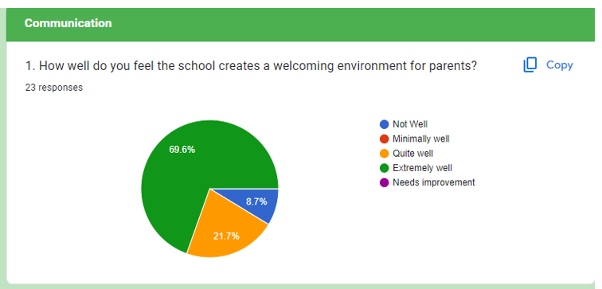

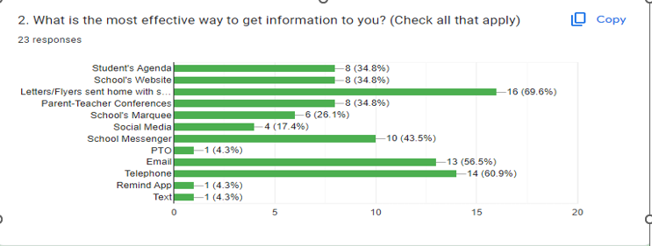

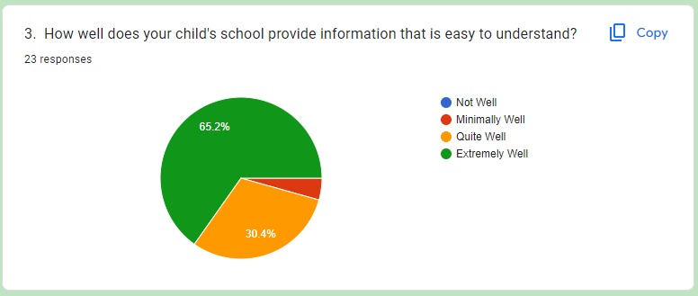

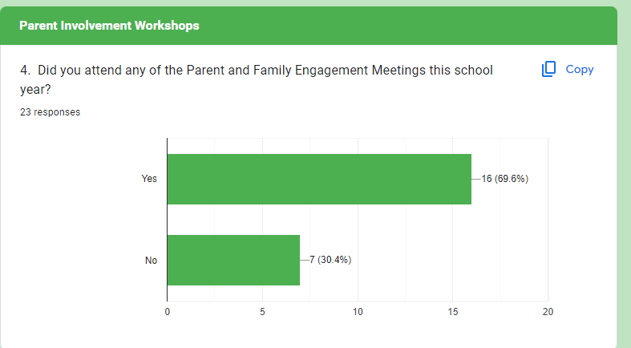
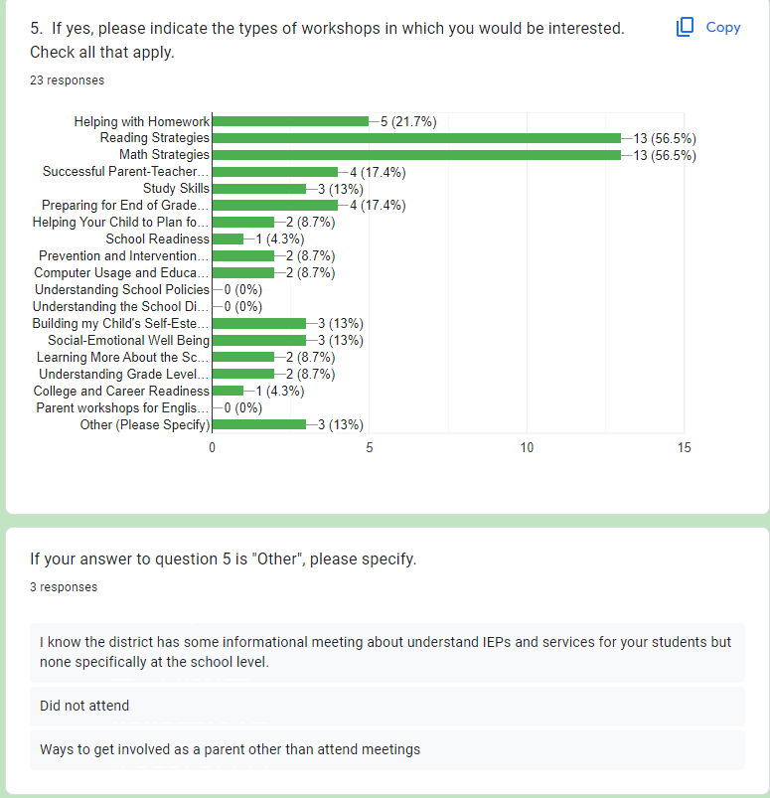
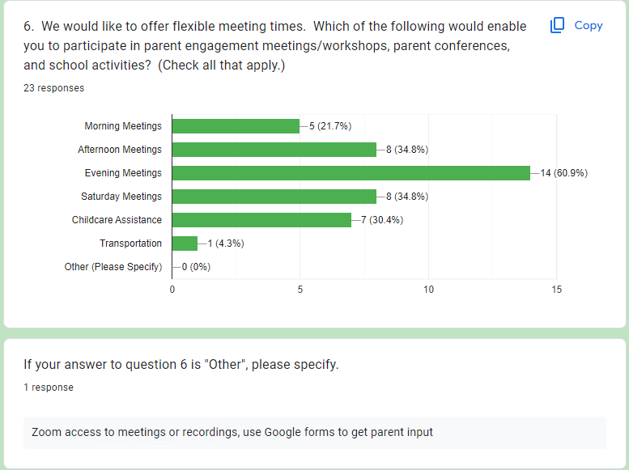
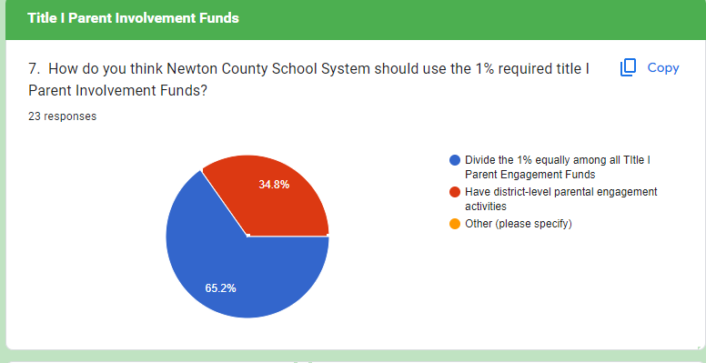
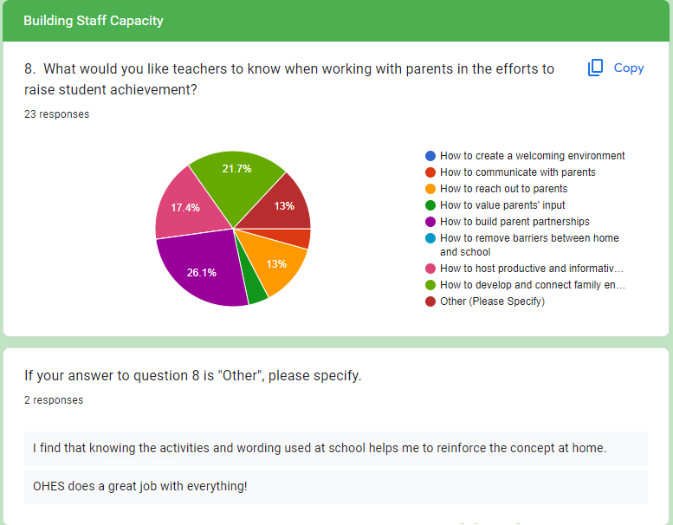

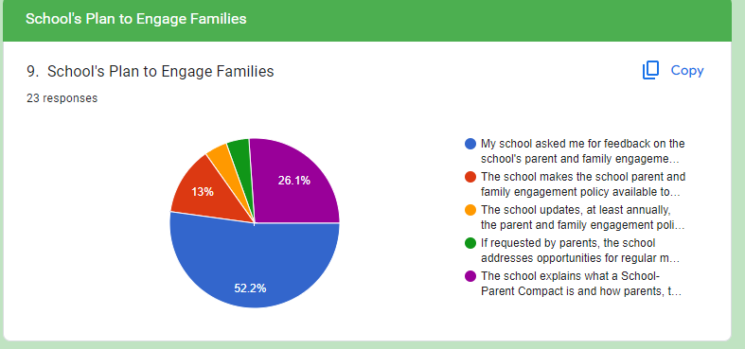
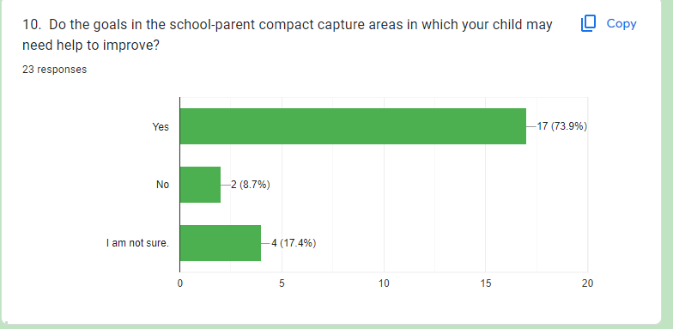

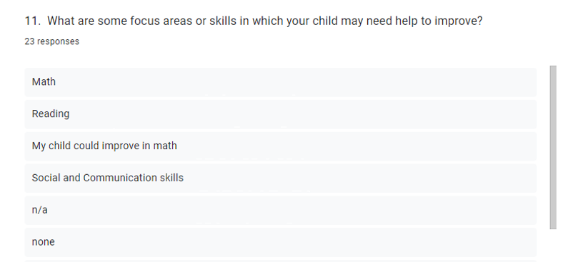
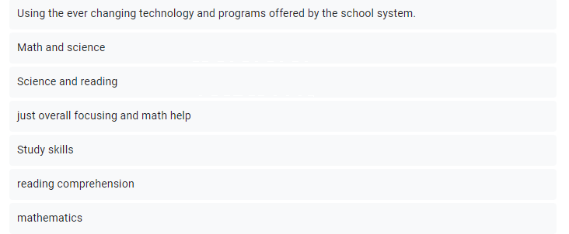
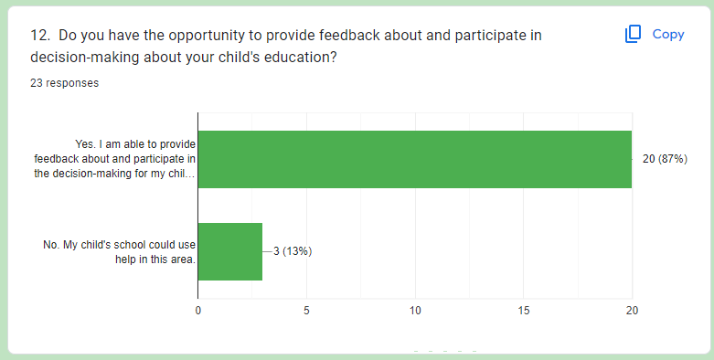

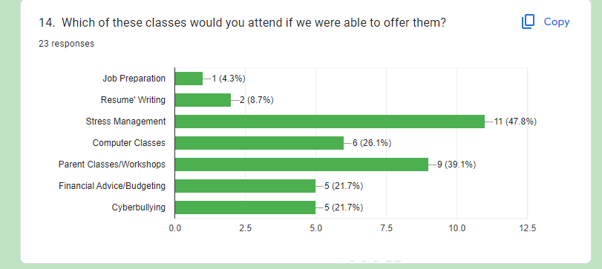
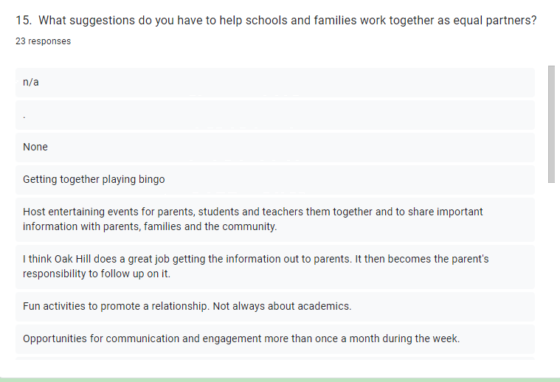
Parent Engagement Survey Summary: We had 23 parent responses to the survey. Approximately 91% of responses indicated parents felt welcome at Oak Hill. Of those who responded 70% had attended at least one of the parent involvement activities. Approximately 57% of responses indicate interest in math workshops and 57% reflect an interest in reading workshops. Both of these are planned for next year. There was also an interest in helping with homework (23%).

Why are students not performing well in Math?
ROOT CAUSE | HOW TO ADDRESS CONCERNS
Students have limited Number Sense in K-3. | Teachers will engage students in number talks/subitizing multiple times a week.
Students cannot compute with whole numbers quickly and accurately. | We will provide a 5-minute practice with computation 3-5 times a week
Students in grades 3-5 struggle to understand and compute with Fractions. | Teachers will use manipulatives to model a progression from concrete, representation, to abstract. Teachers will engage students in number talks multiple times a week.
Students struggle to understand academic vocabulary and understand questions. | Teachers will use explicit vocabulary instruction to help students understand academic vocabulary through the use of word problems 3-5 times a week.
SMART Goal: Students in grades 1-5 will show an increase from Fall 2023 to Spring 2024 of at least 3% in Total Math NPR scores according to IOWA data.

Why are students not performing well in ELA/Reading?
ROOT CAUSE | HOW TO ADDRESS CONCERNS
Lack of attendance and excessive tardiness leads to missed instruction particularly during intervention time. (41% of students had 10 or more absences not including tardies or checkouts.) | Students will be recognized for no more than 2 absences and/or 2 tardies per month.  Expectations will be communicated to families.
Students in grades K-3 have significant deficits in phonics. | Phonics instruction will be implemented for all students K-2 daily. Supplemental phonics materials will be used as needed for intervention.
Students struggle in grades K-5 with reading comprehension. | Oak Hill will participate in a common reading block to maximize reading support. There will also be a common intervention time to enable remediation and extension across the grade level.
Students struggle to understand academic vocabulary and understand questions. | Teachers will use BrainPOP and high complexity texts to expand vocabulary and background knowledge.
SMART Goal: Students in grades 1-5 will show an increase from Fall 2023 to Spring 2024 of at least 3% in Total ELA NPR scores according to IOWA data.

Why are students not performing well in Science?
ROOT CAUSE | HOW TO ADDRESS CONCERNS
Teachers and students need developmentally appropriate materials for teaching and learning Science. | Teachers will investigate and obtain science materials for hands-on learning.
Students struggle to understand academic vocabulary and understand questions. | Teachers will use BrainPOP and high complexity texts to expand vocabulary and background knowledge.
SMART Goal: Seventy percent of students in grades 1-5 will demonstrate overall mastery of grade level Science content by progressing, meeting, or exceeding the standard or by achieving a minimum score of 70 as the final grade.

Why are students not performing well in Social Studies?
ROOT CAUSE | HOW TO ADDRESS CONCERNS
Students have limited background knowledge and struggle to understand academic vocabulary and understand questions. | Teachers will use BrainPOP and high complexity texts to expand vocabulary and background knowledge.  Students will use supplemental reading materials to expand vocabulary and background knowledge in Social Studies.
SMART Goal: Seventy percent of students in grades 1-5 will demonstrate overall mastery of grade level Social Studies content by progressing, meeting, or exceeding the standard or by achieving a minimum score of 70 as the final grade.

Why are students not performing well in Behavior?
ROOT CAUSE | HOW TO ADDRESS CONCERNS
We have a large population of students who have experienced adverse childhood trauma. | We will implement a School-wide positive behavior recognition initiative.
Students struggle with expectations and positive peer interactions. | We will continue to implement a weekly Character Education focus. We will implement a School-wide positive behavior recognition initiative.
SMART Goal: Referrals will decrease by at least 3%, according to the Discipline Incident Summary, from Spring 2023 to Spring 2024.

- School-wide Reform Strategies – Section 1114(b)(7)(A)(i-iii)(I-V)
Address the reform strategies the school will implement to meet the school needs, including a description of how such strategies will:

a). Provide opportunities for all children, including all subgroups of students (economically disadvantage students, students from major racial and ethnic groups, children with disabilities and English learner) defined in section 1111 (c)(2), to meet the State’s challenging academic standards.

b). Use methods and instructional strategies that strengthen an academic program in the school, will increase the amount and quality of learning time, and help provide an enriched and accelerated curriculum, which may include programs, activities, and courses necessary to provide a well-rounded education.
MATH GOAL
Students in grades K-5 will show an increase from Fall 2023 to Spring 2024 a minimum of at least 3 points in cut scores according to Fastbridge AMath benchmark scores.

OVERARCHING MATH PROGRAM
Oak Hill Elementary School teachers use Georgia Department of Education Math Learning Plans, Envision 2020, Moby Max, and number talks to provide students with practice of math concepts using many hands-on experiences that enable students to gain mastery of crucial mathematical skills. Moby Max and Envision 2020 also incorporate opportunities for students to work in a variety of learning situations and provide each student with internet access to many resources that can be used at school or home.
Person(s) Responsible: | Principal, Instructional Coach, K-5 Teachers
Evaluation Methods: | Lesson plans, Observations, Informal/Formal Assessments, Report Card Grades, Usage Reports, Growth Reports
Timeline for Implementation: | August 2023-May 2024
Describe the evidence-based action steps to be taken to achieve the goals.
Evidence Based Strategy  Evidence Level |  | Intervention/Practice  (If Title I Funded, a Logic Model is required.) |  | Funding Source | Resources  Needed
Timed Activities: Regularly include timed activities as one way to build fluency in mathematics. (Tier 1 Strong) |  | Moby Max will be used to help students in grades K-5 grade master state-specific, grade-level academic standards in a fun and engaging manner.  Logic Model Required: ☒ |  | Title I  Funds | Moby Max program  Laptops /Chromebooks  Ipads  Headphones
Help students recognize and articulate mathematical concepts and notation. (Tier 2 Moderate) |  | Interactive Notebooks will be used to support classroom instruction.  Logic Model Required: ☒ |  | Title I  Funds | Paper, pencils, laminating film, interactive notebooks, markers, glue, colored pencils, ink
Systemic Instruction: Prepare problems and use them in whole-class instruction. (Tier I Strong) |  | Activating strategies are teaching strategies that prepare students for learning. Students are prepared for learning by activating an overview of the upcoming learning experience, their prior knowledge, and the necessary vocabulary. We will use BrainPOP as one way to activate the learning process. BrainPOP contains short, animated movies and other materials designed to engage students and assist teachers. BrainPOP videos are aligned to state education standards.  Logic Model Required: ☒ |  | Title I Funds | BrainPOP subscription  Laptops /Chromebooks  Ipads  Active Panel  Headphones
Systemic Instruction: Prepare problems and use them in whole-class instruction. (Tier I Strong) |  | Nearpod will be used to help students in grades 1-5 master state-specific, grade-level academic standards in a fun and engaging manner while developing technology skills.  Logic Model Required: ☐ |  | District Funded | Nearpod subscription  Laptops/Chromebooks  Carts  Headphones
Teach students how to use visual representations. (Tier 1 Strong) |  | Teachers will use a variety of math manipulatives (such as dot cards, ten frames, rekenreks, puzzles, flashcards, index cards, cardstock, and markers, games, etc.) to develop early numeracy and build computational fluency. New manipulatives will be needed to implement the new Learning Plans from GaDoe to teach the new K-12 Math standards.  Logic Model Required: ☒ |  | Title I Funds | Math manipulatives, cardstock, beads, manipulative kits, sticks, markers, clothespins, laminating film, cards, dice, protective sheets, games, copy paper, whiteboards
K: Teach number and operations using a developmental progression. (Tier 2 Moderate) |  | Istation Math will be used to help students in grades 1-5 grade master state-specific, grade-level academic standards in a fun and engaging manner.  Logic Model Required: ☒ |  | Title I Funds | Istation subscription  Laptops/Chromebooks  Carts  Headphones  Chargers
Timed Activities: Regularly include timed activities as one way to build fluency in mathematics. (Tier 1 Strong) |  | ALEKS will be used to help students in grade 4 to master state-specific, grade-level academic standards in a fun and engaging manner.  Logic Model Required: ☒ |  | Title I Funds | ALEKS subscriptions  Laptops/Chromebooks  Carts  Headphones  Chargers
Help students recognize and articulate mathematical concepts and notation. (Tier 2 Moderate) |  | Edulastic will be used to help students in grades 3-5 master grade level standards in math and enhance technology skills.  Logic Model Required: ☒ |  | Title I Funds | Software subscriptions  Chargers  Headphones  Laptops/Chromebooks
Systemic Instruction: Prepare problems and use them in whole-class instruction. (Tier I Strong) |  | Instructional supplies will be used to support the implementation of evidence based instructional strategies and programs during whole/flexible/small group instruction.  Logic Model Required: ☐ |  | Title I, Part A | Notebooks, Paper, Colored Pencils, Highlighters, Glue sticks, Ink, Poster maker printer, Chart paper, Anchor charts, and easels
Assist students in monitoring and reflecting on the problem-solving process. (Tier 1 Strong) |  | Tutoring |  | Title I Part A | Salaries, supplies, manipulatives, chart paper, workbooks, snacks
Supplemental Supports: What supplemental action steps will be implemented for these subgroups?
Economically Disadvantage |  |  | Foster And Homeless
We will provide additional support to students based on individual student needs via supplemental academic programs. |  |  | We will work with the Foster Care and Homeless Liaison to support the goals of improving educational outcomes for homeless and foster care students.
English Learners |  |  | Migrant
ELs will be served by an ESOL-endorsed teacher. Supplemental resources and materials will be purchased using Title III-LEP funds |  |  | We will work with the District’s Migrant Liaison to support the goals of improving educational outcomes for migratory students. We currently do not have any Migrant students in our school.
Race/Ethnicity/Minority |  |  | Students With Disabilities
We will provide additional support to students based on individual student needs via supplemental academic programs. |  |  | Targeted interventions for SWD will be used. IEPs will be implemented with fidelity to provide support on an individual basis in the least restrictive environment.

ELA/READING GOAL
Students in grades K-5 will show an increase from Fall 2023 to Spring 2024 a minimum of at least 3 points in cut scores according to Fastbridge AReading benchmark scores.
OVERARCHING ELA/READING PROGRAM
Oak Hill Elementary School teachers utilize Scholastic Literacy, Next Step Guided Reading, Phonics kits, and Accelerated Reader. These research-based programs encompass all areas of literacy and address the six components of a balanced reading program. These programs link classroom instruction with everyday experiences, authentic literature, and all other areas of the curriculum. Lesson plans based upon the Georgia Standards of Excellence are used to promote student choice, high engagement, and opportunities for independent or shared practice.
Person(s) Responsible: | Principal, Instructional Coach, and K-5 Teachers
Evaluation Methods: | Lesson plans, Observations, Informal/Formal Assessments, Usage Report
Timeline for Implementation: | August 2023-2024
Describe the evidence-based action steps to be taken to achieve the goals.
Evidence Based Strategy  Evidence Level | Intervention/Practice  (If Title I Funded, a Logic Model is required.) | Funding Source | Resources  Needed
K-3rd: Ensure that each student reads connected text every day to support reading accuracy, fluency, and comprehension. (Tier 2 Moderate) | Edulastic will be used to help students in grades 3-5 master grade level standards in reading and enhance technology skills.  Logic Model Required: ☒ | Title I | Edulastic subscriptions  Laptops/Chromebooks  Chargers  Headphones
K-3rd: Teach students to decode words, analyze word parts, and write and recognize words. (Tier 1 Strong) | Istation Reading will be used to help students in grades 1-5 master reading standards, boost comprehension, and increase lexiles.  Logic Model Required: ☒ | Title I | Istation subscriptions  Laptops/Chromebooks  Carts  Adapters
Teach a set of academic vocabulary words intensively across several days using a variety of instructional activities. (Tier 1 Strong) | BrainPop software will be used to help students in grades K-5 increase prior knowledge and expand vocabulary.  Logic Model Required: ☒ | Title I | Brainpop subscription  Laptops/Chromebooks  Ipads  Active Panel  headphones
K-3rd: Teach students how to use reading comprehension strategies. (Tier 3 Promising) | Interactive Notebooks and student learning packets will be used to support classroom instruction.  Logic Model Required: ☐ | Title I, Part A | Paper, pencils, laminating film, interactive notebooks, markers, glue, colored pencils, ink
K-3rd: Establish an engaging and motivating context in which to teach reading comprehension. (Tier 3 Promising) | Moby Max will be used to help students in grades K-5 grade master state-specific, grade-level academic standards in a fun and engaging manner.  Logic Model Required: ☒ | Title I | Moby Max program  Laptops/Chromebooks  Headphones
Provide intensive small-group reading interventions. (Tier 3 Promising) | Independent reading texts and manipulatives are needed to increase reading fluency and reading comprehension. Through the use of independent reading texts students will gain access to cross-curricular content knowledge in math, science, and social studies.  Logic Model Required: ☒ | Title I, Part A | Texts/Books  manipulatives (flash cards, task cards, alphabet magnets, beads)
Provide intensive small-group reading interventions. (Tier 3 Promising) | Reading manipulatives and games will allow students the ability to physically interact with content in a hands-on manner.  Logic Model Required: ☒ | Title I, Part A | Manipulatives  Games  Magnetic letters  Tiles
Teach students to use the writing process for a variety of purposes. (Tier 1 Strong) | Writing workshop materials will be needed to improve writing instruction and cross-curricular content knowledge in math, science and social studies  Logic Model Required: ☐ | Title I, Part A | Chart paper, notebooks, whiteboards,  workbooks, pencils, crayons, paper, manipulatives
K-3rd: Establish an engaging and motivating context in which to teach reading comprehension. (Tier 3 Promising) | Nearpod will be used to help students in grades 1-5 master state-specific, grade-level academic standards in a fun and engaging manner while developing technology skills.  Logic Model Required: ☐ | District Funded | Nearpod subscription  Laptops/Chromebooks  Carts  Headphones
4th-5th: Provide purposeful fluency-building activities to help students read effortlessly in grades 4 and 5. (Tier 1 Strong) | Progress Learning will be used to help students in grades 4-5 master grade level standards in math and enhance technology skills  Logic Model Required: ☒ | Title I, Part A | Progress Learning subscriptions  Laptops/Chromebooks  Headphones
K-3rd: Teach students how to use reading comprehension strategies. (Tier 3 Promising) | Instructional supplies will be used to support the implementation of evidence based instructional strategies and programs.  Logic Model Required: ☐ | Title I, Part A | Notebooks, Paper, Colored Pencils, Highlighters,  Glue sticks, Ink,  Poster maker printer  Chart paper  Anchor charts
K-3rd: Select texts purposefully to support comprehension development. (Tier 4 Has Rationale) | Accelerated Reader software will be used to help students in grades 1-5 increase reading comprehension and vocabulary.  Logic Model Required: ☐ | General Funds | A.R. subscription  Laptops/Chromebooks  Headphones
Assist students in monitoring and reflecting on the problem-solving process. (Tier 1 Strong) | Tutoring | Title I Part A | Salaries, supplies, manipulatives, chart paper, workbooks, snacks
Supplemental Supports: What supplemental action steps will be implemented for these subgroups?
Economically Disadvantage | Foster And Homeless
We will provide additional support to students based on individual student needs via supplemental academic programs. | We will work with the Foster Care and Homeless Liaison to support the goals of improving educational outcomes for homeless and foster care students.
English Learners | Migrant
ELs will be served by an ESOL-endorsed teacher. Supplemental resources and materials will be purchased using Title III-LEP funds. | We will work with the District’s Migrant Liaison to support the goals of improving educational outcomes for migratory students. We currently do not have any Migrant students in our school.
Race/Ethnicity/Minority | Students With Disabilities
We will provide additional support to students based on individual student needs via supplemental academic programs. | Targeted interventions for SWD will be used. IEPs will be implemented with fidelity to provide support on an individual basis in the least restrictive environment.

SCIENCE GOAL
Seventy percent of students in grades K-5 will demonstrate overall mastery of grade level Science content by progressing, meeting, or exceeding the standard or by achieving a minimum score of 70 as the final grade.
OVERARCHING Science PROGRAM
The curriculum in use at Oak Hill Elementary School is McGraw-Hill. This program facilitates student learning and promotes inquiry through the 5E instructional model. A county-provided curriculum map helps to align units of study with quality reading experiences. It also ensures that transient students experience continuity in instruction when they move to other schools within Newton County.
Person(s) Responsible: | Principal, Instructional Coach, and K-5 Teachers
Evaluation Methods: | Observations, Lesson Plans, Informal/Formal Assessments, Professional Learning, Report Card Grades
Timeline for Implementation: | August 2023-May 2024
Describe the evidence-based action steps to be taken to achieve the goals.
Evidence Based Strategy  Evidence Level |  | Intervention/Practice  (If Title I Funded, a Logic Model is required.) |  | Funding Source | Resources  Needed
Teach a set of academic vocabulary words intensively across several days using a variety of instructional activities. (Tier 1 Strong) |  | BrainPOP software will be used to help students in grades K-5 to increase prior knowledge and expand vocabulary.  Logic Model Required: ☒ |  | Title I | BrainPOP  Paper  Pencils/Pens  Laptops/Chromebooks
Grades 4-5: Routinely use a set of comprehension-building practices to help students make sense of the text (Tier 1 Strong) |  | Teachers will integrate science into reading to provide opportunities for students to make authentic connections with self, text, and the world as it relates to scientific concepts. Students experience the content in other subjects and participate in experiments, which allows them to test their hypotheses and build curiosity.  Logic Model Required: ☐ |  | General Funds | Science and lab materials,  Manipulatives,  Storage containers, and  Books/texts
Connect and integrate abstract and concrete representations of concepts. (Tier 3 Promising) |  | Interactive Notebooks will be used to support classroom instruction.  Logic Model Required: ☒ |  | Title 1 | Paper, pencils, laminating film, interactive notebooks, markers, and protective sheets
Provide engaging learning experiences. (Tier 4 Has Rationale) |  | Nearpod will be used to help students in grades 1-5 master state-specific, grade-level academic standards in a fun and engaging manner while developing technology skills.  Logic Model Required: ☒ |  | District Funded | Nearpod subscription  Laptops/Chromebooks  Carts  Headphones
Connect and integrate abstract and concrete representations of concepts. (Tier 3 Promising) |  | Instructional supplies will be used to support the implementation of evidence based instructional strategies and programs.  Logic Model Required: ☐ |  | Title I, Part A | Notebooks, Paper, Colored Pencils, Highlighters,  Glue sticks, Ink,  Poster maker printer  Chart paper  Anchor charts
Supplemental Supports: What supplemental action steps will be implemented for these subgroups?
Economically Disadvantage |  |  | Foster And Homeless
We will provide additional support to students based on individual student needs via supplemental academic programs. |  |  | We will work with the Foster Care and Homeless Liaison to support the goals of improving educational outcomes for homeless and foster care students.
English Learners |  |  | Migrant
ELs will be served by an ESOL-endorsed teacher. Supplemental resources and materials will be purchased using Title III-LEP funds. |  |  | We will work with the District’s Migrant Liaison to support the goals of improving educational outcomes for migratory students. We currently do not have any Migrant students in our school.
Race/Ethnicity/Minority |  |  | Students With Disabilities
We will provide additional support to students based on individual student needs via supplemental academic programs. |  |  | Targeted interventions for SWD will be used. IEPs will be implemented with fidelity to provide support on an individual basis in the least restrictive environment.

SOCIAL STUDIES GOAL
Seventy percent of students in grades K-5 will demonstrate overall mastery of grade level Social Studies content by progressing, meeting, or exceeding the standard or by achieving a minimum score of 70 as the final grade.
OVERARCHING SOCIAL STUDIES PROGRAM
Curricula in use at Oak Hill Elementary School are Gallopade and GA Studies Weekly. These materials facilitate student learning and promote inquiry. A county-provided curriculum map helps to align units of study with quality reading experiences. It also ensures that transient students experience continuity in instruction when they move to other schools within Newton County.
Person(s) Responsible: | Principal, Instructional Coach, and K-5 Teachers
Evaluation Methods: | Lesson plans, Observations, Informal/Formal Assessments, Usage Report
Timeline for Implementation: | August 2023-May 2024
Describe the evidence-based action steps to be taken to achieve the goals.
Evidence Based Strategy  Evidence Level |  | Intervention/Practice  (If Title I Funded, a Logic Model is required.) |  | Funding Source |  |  | Resources  Needed
Teach a set of academic vocabulary words intensively across several days using a variety of instructional activities. (Tier 1 Strong) |  | BrainPOP software will be used to help students in grades K-5 increase prior knowledge and expand vocabulary.  Logic Model Required: ☒ |  | Title I, Part A |  |  | BrainPOP subscription  Laptops/Chromebooks  Headphones  Paper  Pencils/Pens
Ask deep explanatory questions. (Tier 3 Promising) |  | Teachers will plan cross-curricular instruction aligned to Georgia State standards by incorporating concepts into reading and writing.  Logic Model Required: ☐ |  | General Funds |  |  | Social Studies Weekly  Gallopade Books  Supplemental Books
Connect and integrate abstract and concrete representations of concepts. (Tier 3 Promising) |  | Interactive Notebooks will be used to support classroom instruction.  Logic Model Required: ☐ |  | Title 1 |  |  | Paper, pencils, laminating film, interactive notebooks, markers, protective sheets
Grades 4-5: Routinely use a set of comprehension-building practices to help students make sense of the text (Tier 1 Strong) |  | Social Studies lessons will be integrated into ELA/Reading using non-fiction leveled-readers and to ensure that students have access to the content-rich information for comprehension.  Logic Model Required: ☐ |  |  | General Funds |  | Supplemental Texts
Provide engaging learning experiences. (Tier 4 Has Rationale) |  | Nearpod will be used to help students in grades 1-5 master state-specific, grade-level academic standards in a fun and engaging manner while developing technology skills.  Logic Model Required: ☒ |  | District Funded |  | Nearpod subscription, Laptops/Chromebooks  Carts  Headphones
Connect and integrate abstract and concrete representations of concepts. (Tier 3 Promising) |  | Instructional supplies will be used to support the implementation of evidence based instructional strategies and programs.  Logic Model Required: ☐ |  | Title I, Part A |  | Notebooks, Paper, Colored Pencils, Highlighters,  Glue sticks, Ink,  Poster maker printer,  Chart paper,  Anchor charts
Economically Disadvantage |  |  | Foster And Homeless
We will provide additional support to students based on individual student needs via supplemental academic programs. |  |  | We will work with the Foster Care and Homeless Liaison to support the goals of improving educational outcomes for homeless and foster care students.
English Learners |  |  | Migrant
ELs will be served by an ESOL-endorsed teacher. Supplemental resources and materials will be purchased using Title III-LEP funds. |  |  | We will work with the District’s Migrant Liaison to support the goals of improving educational outcomes for migratory students. We currently do not have any migrant students in our school.
Race/Ethnicity/Minority |  |  | Students With Disabilities
We will provide additional support to students based on individual student needs via supplemental academic programs. |  |  | Targeted interventions for SWD will be used. IEPs will be implemented with fidelity to provide support on an individual basis in the least restrictive environment.

OTHER INSTRUCTIONAL METHODS
- Use effective instructional methods that increase the quality and amount of learning time.
- Increase the amount and quality of learning time, such as providing an extended school year, after-school and summer programs, and other opportunities to help provide an enriched and accelerated curriculum.
- Increase the amount and quality of learning time, such as class-size reduction teachers, supplemental teachers, paraprofessionals, etc.
Person(s) Responsible: | Administrators, Instructional Coaches, All Teachers, Title I Parent Contact
Evaluation Methods: | Principal Evaluation, PLC Records, Professional Learning Logs, Feedback,  Report Card Grades
Timeline for Implementation: | August 2023-May 2024
Describe the evidence-based action steps to be taken to achieve the goals.
Evidence Based Strategy  Evidence Level |  | Intervention/Practice  (If Title I Funded, a Logic Model is required.) | Funding Source | Resources  Needed
Assess program performance and use the results to improve the quality of the program. (Tier 4 Has Rationale) |  | The Instructional Coach will assist in building teacher capacity and their understanding of instructional practices as related to the Georgia Standards and Data Driven Instruction. The Instructional Coach will ensure high-quality instruction in classrooms through modeling, co-planning, co-teaching and providing feedback to teachers.  Logic Model Required: ☒ | Title I, Part A | School Supplies (chart paper, markers, tape, Post-it notes, pens, pencils)  Books
Align the Out-of-School-Time program academically with the school day. (Tier 4 Has Rationale) |  | Title I Parent Contact will serve as the liaison between the school and the district. The Title I Contact will be used to assist the principal in carrying out the requirements of the Parent Involvement Program in order to provide parents with academically based strategies to help support parent involvement beyond the school day.  Logic Model Required: ☒ | Title I, Part A | Paper  Pens  Ink  Office Supplies
Adapt instruction to individual and small group needs. (Tier 3 Promising) |  | EIP Teachers will provide additional instructional support to students who are performing below grade level in math, by helping them obtain the necessary academic skills to reach grade level performance.  Logic Model Required: ☐ | General Funds | Paper  Pens  Ink  Office Supplies  Glue Sticks
PARENT AND FAMILY ENGAGEMENT PROGRAM
Person(s) Responsible: | Principal, Title I Parent Contact, and Teachers
Evaluation Methods: | Informal/Formal Assessments, Report Card Grades, Sign-In Sheets, Agendas, Parent Evaluations, Parent Survey, Logic Model
Timeline for Implementation: | August 2023-May 2024
Describe the evidence-based action steps to be taken to achieve the goals.
Intervention/Practice  (If Title I Funded, a Logic Model is required.) |  | Funding Source | Resources  Needed | Funding Source | Resources  Needed
Offer math and reading parent family engagement workshops that provide parents opportunities to acquire necessary information, knowledge, and skills to support their children’s education at home.  Logic Model Required: ☒ |  | Title I, Part A | Paper, Pens, Ink, Manipulatives, books, Light Snacks
Send home grade-specific newsletters, Parents Make a Difference, and calendars (in a format and language that parents can understand) that provide essential information to parents and foster a connection between the classroom and the home.  Logic Model Required: ☒ |  | Title 1 Funds and General School Funds | Parents Makes Difference  Home-School Connections  Nutrition  Nuggets  Communication folders  Ink  Copy paper
The Parent Resource Room will be open to parents throughout the week and parent nights. The Parent Resource Room provides parents with resources for check-out that reinforces those skills that students may need to improve achievement.  Logic Model Required: ☒ |  | Title 1 Funds and General School Funds | Books, Brochures, Academic Games
We will offer in-person and continuous support and training to teachers to assist teachers in building the capacity to work with parents as equal partners.  Logic Model Required: ☐ |  | Title I, Part A | Ppt, Handouts, Articles  Videos
Remind will be used to further support the school’s efforts in activating and sustaining two-way communication between students, families, and educators. Teachers will use this tool to reach out to parents and improve communication with families and students to build partnerships to support academic success.  Logic Model Required: ☐ |  | ESSER Funds  District Funded | Remind Subscription
We will provide continuous communication to parents and families in the quest of achieving academic success for all students to ensure that learning continues beyond the school day.  Logic Model Required: ☒ |  | Title I, Part A | Copy paper  Ink/toner  Printer  Scanner  Remind  School Messenger

PROFESSIONAL LEARNING
Person(s) Responsible: | Principal, Instructional Coach, K-5 Teachers
Evaluation Methods: | Lesson plans, Observations, Informal/Formal, PLC Agendas
Timeline for Implementation: | August 2023-May 2024
Describe the evidence-based action steps to be taken to achieve the goals.
Evidence Based Strategy  Evidence Level |  | Intervention/Practice  (If Title I Funded, a Logic Model is required.) | Funding Source | Resources  Needed
Make data part of an ongoing cycle of instructional improvement. (Tier 4 Has Rationale) |  | Faculty will participate in professional learning with the Digital Learning Coach regarding academic software resources to enhance instruction.  Logic Model Required: ☒ | General Funds | Software subscriptions, Laptops/Chromebooks, Carts, Document Cameras, Headphones
Establish a clear vision for schoolwide data use. (Tier 4 Has Rationale) |  | The Instructional Coach will assist in building teacher understanding of instructional practices as related to the Georgia Standards of Excellence and data driven instruction. The Instructional Coach will ensure high-quality instruction in classrooms through modeling, co-planning, co-teaching, book studies, and providing feedback to teachers.  Logic Model Required: ☒ | Title I, Part A | Chart Paper  Markers  Highlighters  Ink  Pens/Pencils  Sticky Notes  PL Resource Books
Make data part of an ongoing cycle of instructional improvement. (Tier 4 Has Rationale) |  | New teachers will participate in district-funded BEST Teacher Program to work with a school-based mentor in the efforts to assist with day-to-day routines in addition to providing job-embedded professional learning that focuses on new-teacher issues.  Logic Model Required: ☐ | District Funds | Books  PL Supplies
Make data part of an ongoing cycle of instructional improvement. (Tier 4 Has Rationale) |  | Curriculum Planning days are set aside for meetings so teachers in the same subject or grade level can develop a focus and learning environment that proactively identifies and addresses the diverse needs of all learners.  Logic Model Required: ☐ | Title I, Part A | Chart Paper  Markers  Highlighters  Paper Ink  Substitutes

TECHNOLOGY EQUIPMENT TO SUPPORT THE CORE CURRICULUM
Person(s) Responsible: |  |  | Administration, Instructional Coach, K-5 teachers
Evaluation Methods: |  |  | Lesson plans, Informal/Formal Observations, Report Card Grades
Timeline for Implementation: |  |  | August 2023-May 2024
Describe the evidence-based action steps to be taken to achieve the goals.
Intervention/Strategy/Practice  (If Title I Funded, a Logic Model is required.) |  |  |  | Funding Source | Resources Needed
We will use laptops/Chromebooks and accessories such as: laptop carts, surge protectors, computer chargers, adapters, mice, and headphones as part of classroom rotations. Math and ELA Apps/websites that are grade-level specific will be used to build basic foundational and remedial skills through interactive learning.  Logic Model Required: ☐ |  |  |  | Title I, Part A | Laptops/Chromebooks  laptop carts, surge protectors, computer chargers, adapters, mice, headphones, docking stations
We will use iPads and accessories such as: carts, protective covers, and headphones as part of classroom rotations. Math and ELA Apps/websites that are grade-level specific will be used to build basic foundational and remedial skills through interactive learning.  Logic Model Required: ☐ |  |  |  | Title I, Part A | Ipads  Ipad carts, surge protectors, computer chargers, adapters, mice, headphones
Document Cameras will engage the students in the learning process. Teachers and students will use document cameras and docking stations to display work samples, ELA/Reading and Math exemplars, error analysis, and to address multiple learning styles during ELA/Reading and Math instruction.  Logic Model Required: ☐ |  |  |  | General Funds | Document Cameras, computers, laptops, interactive panels, docking stations
Interactive panels will be used to engage students in the learning process. Teachers will use panels to address multiple learning styles during ELA/Reading and Math instruction. Students can engage with the lesson by writing, highlighting, editing, and transforming documents and images.  Logic Model Required: ☐ |  |  |  | District Funded | Interactive panels, active pens/wands  Keyboards  Batteries

STUDENT BEHAVIOR/ATTENDANCE
Person(s) Responsible: | Principal, Attendance committee chair, Teachers
Evaluation Methods: | Discipline Data, Attendance Reports
Timeline for Implementation: | August 2023-May 2024
Evidence-Based Action Steps: Describe the evidence-based action steps to be taken to achieve the goals.
Evidence Based Strategy  Evidence Level | Intervention/Strategy/Practice  (If Title I Funded, a Logic Model is required.) | Funding Source | Resources Needed
Teach and reinforce new skills to increase appropriate behavior and preserve a positive classroom climate. (Tier 3 Promising) | Classes will be recognized through the Class Keys 4 Success program for positive behavior and attendance. Weekly winners will receive incentives such as pencils, snacks, etc.  Logic Model Required: ☐ | General Funds | Incentives
Teach and reinforce new skills to increase appropriate behavior and preserve a positive classroom climate. (Tier 3 Promising) | Students will be recognized for positive behavior through the WOW slip program. Weekly drawings will be conducted, and prizes given as incentives.  Logic Model Required: ☐ | General Funds | Incentives
Teach and reinforce new skills to increase appropriate behavior and preserve a positive classroom climate. (Tier 3 Promising) | We will implement a weekly Character Education focus for all students to model expectations and positive peer interactions.  Logic Model Required: ☐ | General Funds | No Resources Needed
Teach and reinforce new skills to increase appropriate behavior and preserve a positive classroom climate. (Tier 3 Promising) | All students will participate in “Digital’ citizenship training utilizing Nearpod Modules.  Logic Model Required: ☐ | District Funded | Nearpod Subscriptions

BUILDING FAMILY FRIENDLY SCHOOLS
In the section below, describe strategies to build family-friendly schools by providing high-quality customer service.
Front Office Staff:
Our office staff are trained in ways to build family friendly schools such as: having information available for registration, information for those wishing to be employed as a substitute teacher, greeting parents with a smile, and escorting visitors to destinations in the building.
Administrators:
Our administrators are trained periodically on building powerful partnerships with families through face-to-face training, professional reading, and/or professional videos regarding effective communication, greeting parents, etc.
Teachers and staff:
Teachers and staff are trained quarterly on building powerful partnerships with families through face-to-face training, professional reading, and/or professional videos.

- School-wide Reform Strategies – Section 1114(b)(7)(A)(i-iii)(I-V)
Address the reform strategies the school will implement to meet the school needs, including a description of how such strategies will:

c). address the needs of all children in the school, but particularly the needs of those at risk of not meeting the challenging State academic standards through activities which may include -
i). counseling, school-based mental health programs, specialized instructional support services and other strategies to improve students’ skills outside the academic subject areas;
Currently at Oak Hill Elementary School, we offer services that are not Title I funded. These services include character education and Rethink SEL instruction.
ii). preparation for and awareness of opportunities for postsecondary education and the workforce, which may include career and technical education programs and broadening secondary school students’ access to coursework to earn postsecondary credit while still in high school (such as Advanced Placement, International Baccalaureate, dual or concurrent enrollment, or early college high schools;
Periodically, Oak Hill Elementary School will focus on colleges and careers. This focus will include visitors from college and career pathways, research in these areas, an alumni wall of fame, as well as awareness information being shared on the morning news. A School-wide career day is held in the spring. Teachers will also incorporate opportunities in class to develop soft skills such as cooperation, responsibility, perseverance, and time-management.
iii). implementation of a School-wide tiered model to prevent and address problem behavior, and early intervening services, coordinated with similar activities and services carried out under the Individuals with Disabilities Education Act (20 U.S.C. 1400 et seq.);
Oak Hill has a School-wide positive incentive program. Students are recognized for positive behavior through the WOW slip program and the Keys 4 Success Program. Students are recognized weekly on the morning news. Oak Hill also encourages positive behavior through the student of the month program and citizenship awards. Oak Hill students recite the school rules and school pledge daily. New students are introduced to expectations and rules through a video presentation that is also reviewed with ALL students periodically throughout the year. All teachers develop a behavior management plan to reinforce school expectations. When needed, students will progress through the RTI process for additional support in the area of behavior.
iv). professional development and other activities for teachers, paraprofessionals, and other school personnel to improve instruction and use of data from academic assessments, and to recruit and retain effective teachers, particularly in high need subjects;
- We have included teachers, principals, paraprofessionals, and, if appropriate, pupil services personnel, parents, and other staff in our staff development that addresses the root causes of our identified needs.

Root Cause | Professional Learning to Address Root Cause
Students will experience gaps in knowledge due to new math standards being implemented during the 2023-2024 school year. | Teachers will work in PLCs in partnership with the Instructional Coach to answer the four guiding questions of a PLC.
Instruction in appropriate behavior and addressing negative behaviors are impacting instructional time. | The school level guiding coalition will participate in professional learning regarding a Tiered Behavior System as part of the Professional Learning Community and create a subcommittee for behavior.
New teachers need guidance in various instructional areas. | New teachers will participate in monthly PD by the BEST teacher leader.

- We have included teachers in professional development activities regarding the use of academic assessments, to enable them to provide information on, and to improve, the achievement of individual students and the overall instructional program in the following ways: Oak Hill Elementary School has an instructional coach that attends a variety of trainings and re-delivers material to the staff. The instructional coach also goes into classrooms and provides assistance to teachers on these topics. In professional learning communities, teachers are guided by the instructional coach and the administrative team. As assessments are administered, learning communities will work to analyze the data and learn from one another to improve instruction for students.

- We have devoted sufficient resources to effectively carry out professional development activities, recruit and retain effective teachers, particularly in high need subjects in the following ways: the instructional coach is able to attend workshops and trainings in order to bring information back to teachers in a professional learning atmosphere. The resources allotted to the instructional coach such as paper, copies, and books aid in increasing teacher knowledge in order to meet the needs of the students.
v). strategies for assisting preschool children in the transition from early childhood education programs to local elementary school programs.
Oak Hill Elementary offers several opportunities to assist students during their stages of transition. Teachers and staff are available to answer questions for both students and parents in these programs. Children with special needs who receive services through the Babies Can’t Wait Early Intervention Program participate in planned transition meetings coordinated by that agency. Kindergarten Round-Up is advertised in a variety of ways and parents can pre-register their children.

3. School-wide Plan Development– Section 1114(2)(B) (i-iv)
a). Is developed during a 1-year period; unless – the school is operating a School-wide program on the day before the date of the enactment of Every Student Succeeds Act, in which case such school may continue to operate such program, but shall develop amendments to its existing plan during the first year of assistance after that date to reflect the provisions of the section;
Oak Hill’s original Title I School-wide Plan was developed over the course of one school year. The planning process was facilitated by a technical assistance provider who is external to the district and school.
b). Is developed with the involvement of parents and other members of the community to be served and individuals who will carry out such plan, including teachers, principals, other school leaders, paraprofessionals present in the school, administrators (including administrators of programs described in other parts of this title), the local educational agency, to the extent feasible, tribes and tribal organizations present in the community, and , if appropriate specialized instructional support personnel, technical assistance providers, school staff, if the plan relates to a secondary school, students, and other individuals determined by the school;
Oak Hill’s Leadership Team, composed of grade level teachers, paraprofessionals, and administrators, developed the initial Title I School-wide Plan. The Local School Council and PTO representatives discussed and reviewed the plan before it was submitted for approval. The entire faculty also reviewed the Title I Plan draft before it was approved.
c). Remains in effect for the duration of the school’s participation under this part, except that the plan and its implementation shall be regularly monitored and revised as necessary based on student needs to ensure that all students are provided opportunities to meet the challenging State academic standards;
We will monitor our Title I Plan regularly by reviewing data and making adjustments to prioritize our needs with input from all stakeholders. The Title I Plan will be posted on our school’s website to give all stakeholders the opportunity to review and give input. Copies of the Title I plan will be made available at the request of any stakeholder. All stakeholders will be invited to our annual Title I input meeting where they may give feedback on the Title I Plan.
d). Is available to the local education agency, parents, and the public, and the information contained in such plan shall be in an understandable and uniform
The Title I School-wide Plan is e-mailed for review by the Title I Coordinator and the NCSS Central Office staff. The plan is discussed at School Council Meetings, PTO Meetings, and a copy is available for review in the school office and Media Center. The original Title I Plan was made available through a similar process, including placing it on the school’s website.
e). Is developed in coordination and integration with other Federal, State and local services, resources, and programs, such as programs supported under this Act, violence prevention programs, nutrition programs, housing programs, Head Start programs, adult education programs, career and technical education programs, and schools implementing comprehensive support and improvement activities or targeted support and improvement activities under section 1111 (d), if appropriate and applicable.
We will coordinate and integrate available resources and programs to include Title I, Part A, 21st Century Program, Title III, Title IV, Title IX, food and nutrition programs, and other local and state programs to create comprehensive supports aimed to promote school improvement while increasing student achievement.

4. ESSA Requirements to Include in the School-wide Plan- Sections 1112(b)(10) 1116 (b)(1)
a). Jointly develop with, and distribute to, parents and family members of participating children a written parental and family engagement involvement policy, agreed on by such parents, that shall describe the means for carrying out the requirements of Subsections (c) through (f). Parents shall be notified of the policy in an understandable and uniform format and, to the extent practicable, provided in a language the parents can understand. Such policy shall be made available to the local community and updated periodically to meet the changing needs of parents and the school.
Response:
All students participating in the Title I, Part A program, and their families will be encouraged to fully participate in all parent and family engagement opportunities. Oak Hill Elementary School will provide full opportunity for the participation of parents and family members by…

Linked to Learning Meetings
- We will provide assistance to parents regarding understanding the state standards, state and local assessments, provide materials and training to help parents work with their children to improve their achievement (including education about the harms of copyright piracy), as appropriate, to foster parent and family engagement using primary and secondary methods.
Annual Title I Parent Orientation
- Invite all parents in multiple ways to our annual parent orientation meeting, at a convenient time, to inform parents about the school’s Title I program, the nature of the Title I program, the parents’ requirements and the school parent and family engagement policy, the School-wide plan, and the school-parent compact.
Accessibility
- We will share information related to school and parent programs, meetings, and other activities to the parents of participating children (including parents and family members who have limited English proficiency, parents and family members with disabilities, and parents and family members of migratory children) in a format and, to the extent practicable, in a language the parents can understand.
Annual Parent Input Meeting
- Jointly developing with parents of participating children a school-parent compact that outline how parents, the entire school staff, and students will share the responsibility for improved student academic achievement and the means by conducting an annual parent input meeting and by providing feedback forms on our school’s website, in our front office or parent resource room.
Coordinating Programs
- Coordinating and integrating parental involvement programs and activities with other Federal, State, and local programs, including public preschool programs, and conducting other activities, such as parent resource centers, that encourage and support parents to fully participate in the education of their children.
Flexible Meeting Times
- We will offer a flexible number of meetings, such as meetings in the morning or evening, and may provide, with funds provided under Title I, transportation, childcare, or home visits.
Other Reasonable Support
- Providing such other reasonable support for parental involvement activities, as parents may request.

b). If a middle or high school, describe how the school will implement strategies to facilitate effective transitions for students from middle grades to high school and from high school to postsecondary education including, if applicable—
- through coordination with institutions of higher education, employers, and other local partners; and
Response:
5th Grade to Middle School
NCSS pays for a bus and takes the students to spend a half-day at the middle school that they will attend. More than 90% of our students attend Veterans Memorial Middle. A tour of the facility is provided, including a brief overview of a typical middle school day. Flyers are distributed to the rising sixth graders about summer day camp and parents are encouraged to participate. A summer reading list is also provided at this time. This event is held at the end of May.
- through increased student access to early college high school or dual or concurrent enrollment opportunities, or career counseling to identify student interests and skills
Response: N/A
5. Evaluation of the School-wide Plan—34 CFR § 200.26
a). Address the regular monitoring and implementation of, and results achieved by, the School-wide program, using data from the State’s annual assessments and other indicators of academic achievement.

b). Determining whether the School-wide program has been effective in increasing the achievement of students in meeting the challenging State academic standards, particularly for those students who had been farther from achieving the standards.

c). Describe how the School-wide plan will be revised, as necessary, based on regular monitoring to ensure continuous improvement of students in the School-wide program.
Response: We plan to evaluate our plan yearly using data from the State’s assessments, other student performance data, including perception data to determine if the School-wide program has been effective in addressing the areas of need. We will use the Title I Program Evaluation and Logic Model evaluations to determine if the identified strategies/interventions/activities were effective in addressing the major problem areas and root causes as identified in our Comprehensive Needs Assessment. We will revise our plan during the Annual Summer Planning meeting and as new data becomes available.

We are using evidence-based or other effective strategies to improve student achievement using logic models.

See Appendix for Instructional Coach Logic Model
See Appendix for Professional Learning Logic Model
See Appendix for Building Parent Capacity Logic Model
See Appendix for Building Staff Capacity Logic Model
See Appendix for Parent Involvement Survey Logic Model
See Appendix for Software Logic Model (All software programs must have a separate logic model)

TITLE I INSTRUCTIONAL COACH
MODEL | RESPONSES
Goal: | Students in grades K-5 will show an increase from Fall 2023 to Spring 2024 a minimum of at least 3 points in cut scores according to Fastbridge aReading and AMath benchmark scores.
Intervention/Strategy/Practice: | The Instructional Coach will assist in building teacher capacity and their understanding of instructional practices as related to the Georgia Standards of Excellence and data driven instruction. The Instructional Coach will ensure high-quality instruction in classrooms through modeling, co-planning, co-teaching and providing feedback to teachers.
Current Research Available that demonstrated rationale that suggests it may work:
Response:
- Instructional Coaching
By: Lucy Steiner, Julie Kowal
http://www.readingrockets.org/article/instructional-coaching
- Three Steps to Great Coaching
http://cabooseit.s3.amazonaws.com/makes_sense_strategies/3-steps-to-great-coaching.pdf
- Marzano, R. J., Pickering, D., & Pollock, J. E. (2001). Classroom instruction that works: Research-based strategies for increasing student achievement. Alexandria, VA: Association for Supervision and Curriculum Development.
Is there an ESSA Rating in place for this software? If so, what is it? | Strong Evidence ☐  Moderate Evidence☐  Minimal Evidence☐  No ESSA Rating Exist: ☒
Intervention Population: | K-5
Person Responsible: | Principal Instructional Coach
Implementation Plan of Action:
Response:
The instructional coach shall meet with teachers twice a month to provide professional development. The coach shall also conduct observations, provide feedback, and model research based instructional strategies. The instructional coach shall keep a log of all professional development activities and completed walk-through observations.
How will success be measured? What is the school’s theory of change for this intervention? | Success will be measured through Fastbridge data. Oak Hill theorizes that student achievement will increase as a result of this intervention.
What are the outcomes or milestones that will evaluate success? | Fastbridge data will increase by a minimum of 3points in ELA and Math.
Progress Monitoring Dates: | Beginning of the Year: November 2023  End of Year: May 2024
Evidence-Based Evaluation | Due: May 20, 2024

PROFESSIONAL LEARNING
MODEL | RESPONSES
Goal: | Students in grades K-5 will show an increase from Fall 2023 to Spring 2024 a minimum of at least 3 points in cut scores according to Fastbridge Areading and AMath benchmark scores.
Intervention/Strategy/Practice: | Professional Learning
Current Research Available that demonstrated rationale that suggests it may work:
Marzano, R. J., Pickering, D., & Pollock, J. E. (2001). Classroom instruction that works: Research-based strategies for increasing student achievement. Alexandria, Va: Association for Supervision and Curriculum Development.

Five Phases of Professional Development :North Central Regional Educational Laboratory
http://www.readingrockets.org/article/five-phases-professional-development

Is there an ESSA Rating in place for this software? If so, what is it? | Strong Evidence ☐  Moderate Evidence☐  Minimal Evidence☐  No ESSA Rating Exist: ☒
Intervention Population: | Administration and certified teachers
Person Responsible: | Instructional Coaches, Administration
Implementation Plan of Action:
- Gather information through walkthroughs, observations, classroom data, and surveys to determine professional learning needs
- Determine which staff will benefit from the professional learning session
- Identify objectives and measurable evidence for building teacher capacity and student achievement.
- Specify additional learning opportunities and follow-up sessions to support implementation, plan for differentiated opportunities when necessary
- Identify and allocate resources to properly support professional learning
- Determine how professional learning will be evaluated
How will success be measured? What is the school’s theory of change for this intervention? | - Sign in sheets from each Professional Learning activity  - Walkthrough Forms/Data  - Evaluation Forms
What are the outcomes or milestones that will evaluate success? | End of Year: Students in grades K-5 will show an increase from Fall 2023 to Spring 2024 a minimum of at least 3 points in cut scores according to Fastbridge Areading and AMath benchmark scores.
Progress Monitoring Dates: | Beginning of the Year: October 2023  Middle of the Year: January 2024  End of Year: May 2024
Evidence-Based Evaluation | Due May 20, 2024

TITLE I PARENT ENGAGEMENT PROGRAM
BUILDING PARENT CAPACITY
MODEL | RESPONSES
Goal: | To have at least 33% of parents participate in primary building parent capacity activities as measured by parent meeting attendance by the end of the 2023-2024 school year.
Intervention/Strategy/Practice: | Building Parent Capacity using Primary and Secondary Methods
Current Research Available that demonstrated rationale that suggests it may work:
Parent involvement strategies in urban middle and high schools in the Northeast and Islands Region https://ies.ed.gov/ncee/edlabs/regions/northeast/pdf/REL_2009069.pdf

Partners Education in A Dual Capacity-Building Framework for Family–School Partnerships https://www2.ed.gov/documents/family-community/partners-education.pdf
Is there an ESSA Rating in place for this software? If so, what is it? | Strong Evidence ☐  Moderate Evidence☐  Minimal Evidence☐  No ESSA Rating Exist: ☒
Intervention Population: | ☒K-5 ☐6-8 ☐9-12
Person Responsible: | Principal, Instructional Coach, Title I Parent Contact, Classroom Teachers
Implementation Plan of Action:
- Convene an annual parent orientation that informs parents about the Title I Program, the parents’ requirements, the school parent and family engagement policy, the School-wide plan, and the school-parent compact.

- Provide parents with opportunities to acquire necessary information and skills to support their children’s education at home and at school by implementing purposely designed parent and family engagement opportunities that impact student achievement.

- Review grade-level content area data and determine the skills/focus areas to strengthen school-improvement goals. Use the parent and family engagement planning forms to develop workshops that share strategies and activities linked to the skills/focus areas in the efforts to build the capacity of the parents to complete the strategies/activities with their child effectively.

- Provide continuous communication with parents via flyers, handouts, weekly folders, brochures, emails, text messages, social media posts, website, parent portal or newsletters that share links to videos and tip sheets that promote effective school-parent partnerships.

- Host School-wide parent-teacher conference days to share student progress at school, share academic and/or behavioral strategies and activities to propel students towards academic success. Teachers also discuss the Title I school-parent compact.

- Inform and invite parents to our Parent Resource Room that provides parents and families with a variety of materials and resources to help support specific academic needs.

- Convene an annual parent input meeting to gather feedback on the Title I Program, school and LEA parent and family engagement policies, the School-wide plan, and the school-parent compact, building staff capacity, 1% parent budget, and the CLIP.
How will success be measured? What is the school’s theory of change for this intervention? | We will use the feedback gathered from parent meeting evaluations, stakeholder meetings, and the parent surveys to evaluate the effectiveness of our Parent and Family Engagement Program.  We theorize that parents will become supporters, encouragers, monitors, advocates, decision makers, and collaborators in the efforts to increase student achievement.
What are the outcomes or milestones that will evaluate success? | Higher grades and test scores, high school attendance, greater likelihood of graduating from high school, better chance of postsecondary enrollment, and fewer discipline issues.

TITLE I PARENT ENGAGEMENT PROGRAM BUILDING STAFF CAPACITY
MODEL |  | RESPONSES
SMART Goal: |  | To provide four or more opportunities to build staff capacity to work with parents as equal partners by the end of the 2023-2024 school year.
Intervention/Strategy/Practice: |  | Building staff capacity using primary and secondary methods.
Current Research Available that demonstrated rationale that suggests it may work:
Parent involvement strategies in urban middle and high schools in the Northeast and Islands Region https://ies.ed.gov/ncee/edlabs/regions/northeast/pdf/REL_2009069.pdf

Partners Education in A Dual Capacity-Building Framework for Family–School Partnerships https://www2.ed.gov/documents/family-community/partners-education.pdf

Is there an ESSA Rating in place for this software? If so, what is it? |  | Strong Evidence ☐  Moderate Evidence☐  Minimal Evidence☐  No ESSA Rating Exist: ☒
Intervention Population: |  | ☒K-5 ☐6-8 ☐9-12
Person Responsible: |  | Principal, Instructional Coach, Title I Parent Contact, Classroom Teachers
Implementation Plan of Action:
Primary Method  In-Person Faculty Meeting | 1st Nine Weeks |  | Due by August 31 of each school year | Powerful Partnerships:  Staff Parent and Family Engagement Orientation
*Secondary Method  Handouts, Tip Sheets, Videos | 2nd Nine Weeks |  | Due by the end of the 2nd nine weeks | Optional tools to address topics identified with the assistance of parents.
Primary Method  In-Person Meeting | 3rd Nine Weeks |  | Due by January 31 of each school year | Powerful Partnerships:  Building Powerful Partnerships: School Parent Compacts
*Secondary Method  Handouts, Tip Sheets, Videos | 4th Nine Weeks |  | Due by the end of the 4th nine weeks | Optional tools to address topics identified with the assistance of parents.
How will success be measured? What is the school’s theory of change for this intervention? | We will measure the success of these sessions by having each participant complete an evaluation form. We will also collect feedback after each secondary method on how we can use the strategies shared to enhance our parent and family engagement program.  We theorize that our faculty and staff will provide high-quality customer service, honor and recognize families’ funds of knowledge, connect family engagement to student learning, and create a welcoming and inviting school culture.
What are the outcomes or milestones that will evaluate success? | Parents and the school will be able to work with each other as equal partners in the efforts to increase student achievement.  The students’ education becomes a shared responsibility.
Evidence-Based Evaluation | May 25, 2024

TITLE I PARENT ENGAGEMENT PROGRAM
MODEL | RESPONSES
SMART Goal: | To have at least 33% of parents that offer input on our Title I Parent and Family Engagement Program as measured by the 2023-2024 Parent and Family Engagement Survey.
Intervention/Strategy/Practice: | Parent Survey
Current Research Available that demonstrated rationale that suggests it may work:
Partners Education in A Dual Capacity-Building Framework for Family–School Partnerships https://www2.ed.gov/documents/family-community/partners-education.pdf
Is there an ESSA Rating in place for this software? If so, what is it? | Strong Evidence ☐ Moderate Evidence☐ Minimal Evidence☐ No ESSA Rating Exist: ☒
Intervention Population: | ☒K-5 ☐ 6-8 ☐9-12
Person Responsible: | Principal, Instructional Coach, Title I Parent Contact, Classroom Teachers
Implementation Plan of Action:
- Offer ongoing opportunities to build the capacity of parents and staff to work together as equal partners by focusing on the following areas:
- Communication
- Building Parent Capacity - Parent involvement workshops, conferences, and activities
- Flexible Meeting Times
- Title I Parent Involvement Fund
- Building Staff Capacity
- The Parent and Family Engagement Survey is designed to be a tool that produces family and staff capacity outcomes for Effective Family-School Partnerships that support student achievement and school improvement.
How will success be measured? What is the school’s theory of change for this intervention?
We will measure the success of these sessions by having at least 33% of our parents and family complete the survey by the end of the 2023-2024 school year. We theorize that parents and the school will be able to work with each other as equal partners in the efforts to increase student achievement. The students’ education becomes a shared responsibility.
What are the outcomes or milestones that will evaluate success?
Family and Staff Capacity Outcomes  School and Program Staff Who Can:  - Honor and recognize families’ funds of knowledge  - Connect family engagement to student learning  - Create a welcoming and inviting school culture |  |  | Families who can negotiate multiple roles  Supporters  Encouragers  Monitors  Advocates  Decision Makers  Collaborators
2023-2024 Student Enrollment
2023-2024 # of Parents who took the survey

SOFTWARE: ALEKS
MODEL | RESPONSES
Goal: | Students in grades 4-5 will show an increase from Fall 2023 to Spring 2024 a minimum of at least 3 points in cut scores according to Fastbridge Areading and AMath benchmark scores.
Describe Intervention/Strategy/Practice that this software will be used as a resource: | ALEKS will be used to help students in grades 4-5 master state-specific, grade-level academic standards in a fun and engaging manner.
Current Research Available that demonstrated rationale that suggests it may work:
https://www.aleks.com/about_aleks/Science_Behind_ALEKS.pdf
Cosyn, E., & Thiéry, N. (2000). A Practical Procedure to Build a Knowledge Structure. Journal of Mathematical Psychology, 44, 383-407
What does research say about how to close the math achievement gap?
https://ies.ed.gov/ncee/edlabs/regions/northeast/AskAREL/Response/94
Response: The complex educational software based on Knowledge Space Theory is capable of efficiently and accurately assessing knowledge in various disciplines, ranging from mathematics and the natural sciences to selected topics in business and the social sciences.
Is there an ESSA Rating in place for this software? If so, what is it? | Strong Evidence☒  Moderate Evidence☐  Promising Evidence☐  No ESSA Rating Exist: ☐
Intervention Population: | 4-5
Person Responsible: | Classroom Teachers
Implementation Plan of Action:
Response: Students will use ALEKS software as needed in grades 4-5 to develop math skills. Students will be assessed twice a year using Fastbridge. Pretest data will be gathered in the fall using Fastbridge Cut scores. Post-test data will be gathered in the spring using Fastbridge AMath scores.
How will success be measured? What is the school’s theory of change for this intervention? | Students will increase their math scores as measured by the Fastbridge.
What are the outcomes or milestones that will evaluate success? | End of Year: Students will increase a minimum of 3 points in their cut scores as measured by Fastbridge.
Progress Monitoring Dates: | Beginning of the Year: September 2023  Middle of the Year: January 2024  End of Year: May 2024
Evidence-Based Evaluation | May 20, 2024

SOFTWARE: BrainPOP
MODEL | RESPONSES
Goal: | Students in grades K-5 will show an increase from Fall 2023 to Spring 2024 a minimum of at least 3 points in cut scores according to Fastbridge Areading and AMath benchmark scores.
Describe Intervention/Strategy/Practice that this software will be used as a resource: | BrainPOP helps develop students’ prior knowledge and academic vocabulary in all subject areas.
Current Research Available that demonstrated rationale that suggests it may work:
BrainPOP is an instructional tool for activating prior knowledge and developing vocabulary knowledge. Research has demonstrated strong evidence (per ESSA rating guidelines). https://about.brainpop.com/research/
Gersten, Russell, (December 2007) Effective Literacy and English Language Instruction for English Learners in the Elementary Grades. NCEE 2007-4011 U.S. Department of Education. Obtained from https://ies.ed.gov/ncee/wwc/Docs/PracticeGuide/20074011.pdf
Marzano, R. J., Pickering, D., & Pollock, J. E. (2001). Classroom instruction that works: Research-based strategies for increasing student achievement. Alexandria, VA: Association for Supervision and Curriculum Development.
Is there an ESSA Rating in place for this software? If so, what is it? | Strong Evidence ☐  Moderate Evidence☒  Promising Evidence☐  No ESSA Rating Exist: ☐
Intervention Population: | K-5
Person Responsible: | Classroom teacher
Implementation Plan of Action:
Response:
- Teachers will use BrainPOP videos and quizzes weekly to activate student learning and develop vocabulary.
- Pretest data will be gathered in the Fall using Fastbridge reports.
- Post-test data will be gathered in the Spring using Fastbridge Assessment reports.
How will success be measured? What is the school’s theory of change for this intervention? | Teachers in grades K-5 will increase the number of logins, video views, quizzes, and games throughout the year to assist in vocabulary development.
What are the outcomes or milestones that will evaluate success? | The end of the year outcome will be measured by the Fastbridge Assessment data to show that student achievement increased a minimum of 3 points by the end of the school year.
Progress Monitoring Dates: | Beginning of the Year: October 2023  Middle of the Year: January 2024  End of Year: May 2024
Evidence-Based Evaluation | Due: May 2024

SOFTWARE: Edulastic
MODEL | RESPONSES
Goal: | Students in grades 3-5 will show an increase from Fall 2023 to Spring 2024 a minimum of at least 3 points in cut scores according to Fastbridge Areading and AMath benchmark scores.
Describe Intervention/Strategy/Practice that this software will be used as a resource: | Edulastic will be used to help students in grades 3-5 master state standards in reading and boost technology skills in an engaging way.
Current Research Available that demonstrated rationale that suggests it may work:
https://nwcommons.nwciowa.edu/cgi/viewcontent.cgi?article=1221&context=education_masters
https://files.eric.ed.gov/fulltext/ED606140.pdf
Is there an ESSA Rating in place for this software? If so, what is it? | Strong Evidence ☐  Moderate Evidence☐  Minimal Evidence☐  No ESSA Rating Exist: ☒
Intervention Population: | 3-5
Person Responsible: | Principal and Teachers
Implementation Plan of Action:
- Pre-test data will be gathered in September from Fall Fastbridge Reports.
- Students will utilize software approximately 20 minutes per week.
- Post-test data will be gathered in the Spring through the analysis of Fastbridge.

How will success be measured? What is the school’s theory of change for this intervention? | Student success will be measured at the end of the year using Fastbridge. The school theorizes that the Edulastic software program will help students increase student achievement in reading through the mastery of standards.
What are the outcomes or milestones that will evaluate success? | Students in grades K-5 will show an increase from Fall 2023 to Spring 2024 a minimum of at least 3 points in cut scores according to Fastbridge Areading and AMath benchmark scores..
Progress Monitoring Dates: | Beginning of the Year: October 2023  Middle of the Year: January 2024  End of Year: May 2024
Evidence-Based Evaluation | May 20, 2024

Instructional Supports, Books and Supplies
MODEL | RESPONSES
Goal: | Students in grades K-5 will show an increase from Fall 2023 to Spring 2024 a minimum of at least 3 points in cut scores according to Fastbridge Areading and AMath benchmark scores.
Intervention/Strategy/Practice: | Incorporating technology, informational, and Literary books into teaching and learning practices
Current Research Available that demonstrated rationale that suggests it may work:
Why Do We Need Technology Integration?: The myriad benefits of integrating technology into the classroom.https://www.edutopia.org/technology-integration-guide-importance
Technology use in instruction and teacher perceptions of school support for technology use in Iowa high schools https://ies.ed.gov/ncee/edlabs/projects/project.asp?projectID=4599
Improving Adolescent Literacy: Effective Classroom and Intervention Practices Improving Adolescent Literacy: Effective Classroom and Intervention Practices https://ies.ed.gov/ncee/wwc/docs/practiceguide/adlit_pg_082608.pdf
Foundational Skills to Support Reading for Understanding in Kindergarten Through 3rd Grade
https://ies.ed.gov/ncee/wwc/Docs/practiceGuide/wwc_foundationalreading_040717.pdf

How to Get the Benefits of Interactive Notebooks in Digital Formats
https://www.edutopia.org/article/how-get-benefits-interactive-notebooks-digital-formats

Is there an ESSA Rating in place for this software? If so, what is it? | Strong Evidence ☐  Moderate Evidence☐  Minimal Evidence☐  No ESSA Rating Exist: ☒
Intervention Population: | ☒ K-5 ☐ 6-8 ☐9-12
Person Responsible: | Classroom Teacher, Paraprofessional, Administration
Implementation Plan of Action:
- Collect baseline data using formal and informal assessments.
- Establish benchmarks for the year.
- Incorporate the use of technology, books (informational and literary), and interactive notebooks into teaching and learning practices through various instructional practices to include:
  - Whole Class Instruction- Whole class instruction brings teachers, techniques, students, and a shared learning goal together via direct, explicit instruction
  - Small Group Instruction- Small group instruction usually follows whole group instruction to reinforce or reteach specific skills and concepts and provides a reduced student-teacher ratio.
  - Flexible Grouping-Flexible Grouping ensures that students are receiving instruction that is tailored to their individual needs. The groups change according to the results of informal/formal assessments. This model of instruction emphasizes intervention rather than remediation
  - Extended Learning – Extended learning refers to any educational program or strategy intended to increase the amount of time students are learning, especially for the purposes of improving academic achievement and test scores, or reducing learning loss, learning gaps, and achievement gaps.
- Progress monitor to analyze student learning and to assess effectiveness of the learning tools.
- Adjust teaching and learning practices.
- Progress monitor to analyze student learning and to assess effectiveness of the learning tools after adjustments
- Complete a final assessment of student learning.
- Communicate progress with parents, administrators, and other related staff.

How will success be measured? What is the school’s theory of change for this intervention? | Success will be measured using formal and informal assessments. The team theorizes that providing hands on tools that support all modalities of learning will help to increase student achievement.
What are the outcomes or milestones that will evaluate success? | Success will be evaluated based on the meeting of the intervention/strategy goal.
Progress Monitoring Dates: | Beginning of Year: October 2023  Mid-Year: January 2024  End of Year: May 2024
Evidence-Based Evaluation | Due May 20, 2024

SOFTWARE: Istation Math
MODEL | RESPONSES
Goal: | Students in grades K-5 will show an increase from Fall 2023 to Spring 2024 a minimum of at least 3 points in cut scores according to Fastbridge Areading and AMath benchmark scores.
Describe Intervention/Strategy/Practice that this software will be used as a resource: | Istation Math will be used to help students in grades K-5 grade master state-specific, grade-level academic standards in a fun and engaging manner.
Current Research Available that demonstrated rationale that suggests it may work:
https://info.istation.com/research-studies#validity_and_effectiveness_studies

https://www.smu.edu/-/media/Site/Simmons/Research/RME/docs/16-06-ISIP-Math_Validity-Studies_ExtTR__vFinal.ashx?la=en
Response:
The generalizability and reliability of ISIP Math within this study is moderate to strong across all grade levels.
Is there an ESSA Rating in place for this software? If so, what is it? | Strong Evidence ☐  Moderate Evidence☒  Minimal Evidence☐  No ESSA Rating Exist: ☐
Intervention Population: | K-5
Person Responsible: | Principal and Teachers
Implementation Plan of Action:
Response: Students will utilize the software approximately 30 minutes per week.
How will success be measured? What is the school’s theory of change for this intervention? | Students will increase mastery of state math standards, achieve better grades, and achieve increased test scores.
What are the outcomes or milestones that will evaluate success? | End of Year: Students in grades K-5 will show an increase from Fall 2023 to Spring 2024 a minimum of at least 3 points in cut scores according to Fastbridge AMath benchmark scores.
Progress Monitoring Dates: | Beginning of the Year: September 2023  Middle of the Year: January 2024  End of Year: May 2024
Evidence-Based Evaluation | May 20, 2024

SOFTWARE: Istation Reading
MODEL | RESPONSES
Goal: | Students in grades K-5 will show an increase from Fall 2023 to Spring 2024 a minimum of at least 3 points in cut scores according to Fastbridge Areading benchmark scores.
Describe Intervention/Strategy/Practice that this software will be used as a resource: | Istation Reading will be used to help students in grades K-5 master state-specific, grade-level academic standards in a fun and engaging manner.
Current Research Available that demonstrated rationale that suggests it may work:
Response:
https://info.istation.com/research-studies#validity_and_effectiveness_studies
The generalizability and reliability of ISIP Reading is proven to be a valid and
reliable assessment of literacy skills (Mathes, Toregson, & Herron, 2011).
https://www.istation.com/Content/downloads/studies/G1-8_TX_Growth.pdf

Is there an ESSA Rating in place for this software? If so, what is it? | Strong Evidence ☐  Moderate Evidence☒  Minimal Evidence☐  No ESSA Rating Exist: ☐
Intervention Population: | K-5
Person Responsible: | Principal and Teachers
Implementation Plan of Action:
- Pre-test data will be gathered in October by means of Fastbridge reports.
- Students will use Istation software as needed in grades K-5 to develop skills.
- Students will utilize the software approximately 30 minutes a week.
- Software usage will be monitored periodically by administration through Istation Usage reports and Lexile growth reports.
- Post assessment data/growth report obtained from Fastbridge AReading will be used to determine effectiveness.
How will success be measured? What is the school’s theory of change for this intervention? | Success will be measured through a review of the pre/post test data from Fastbridge. The Istation software program helps increase student achievement in reading.
What are the outcomes or milestones that will evaluate success? | The pre/post test results from the software program will be used to evaluate the success of this intervention.
Progress Monitoring Dates: | Beginning of the Year: October 2023  Middle of the Year: January 2024  End of Year: May 2024
Evidence-Based Evaluation | Due May 2024

SOFTWARE: MobyMax
MODEL | RESPONSES
Goal: | Students in grades K-5 will show an increase from Fall 2023 to Spring 2024 a minimum of at least 3 points in cut scores according to Fastbridge Areading and AMath benchmark scores.
Describe Intervention/Strategy/Practice that this software will be used as a resource: | MobyMax will be used to help students in grades K-5 master state-specific, grade-level academic standards in a fun and engaging manner.
Current Research Available that demonstrated rationale that suggests it may work:
https://www.mobymax.com/pedagogy
Response: Students who have spent just 20 hours using MobyMax average one full grade-level increase in language. These results are due to MobyMax’s pedagogy, which incorporates multiple research-based techniques that have proven highly effective in increasing student achievement. MobyMax’s pedagogy incorporates the most effective practices for increasing student outcomes as identified by Professor John Hattie’s exhaustive research that synthesized over 1,000 meta-analyses of over 50,000 studies.
Is there an ESSA Rating in place for this software? If so, what is it? | Strong Evidence ☒  Moderate Evidence ☐  Minimal Evidence☐  No ESSA Rating Exist: ☐
Intervention Population: | K-5
Person Responsible: | Principal and Teachers
Implementation Plan of Action:
Response: Students will utilize the software approximately 30 minutes per week.
How will success be measured? What is the school’s theory of change for this intervention? | Students will increase mastery of state math standards, achieve better grades, and achieve increased test scores.
What are the outcomes or milestones that will evaluate success? | End of Year: Students in grades K-5 will show an increase from Fall 2023 to Spring 2024 a minimum of at least 3 points in cut scores according to Fastbridge, aReading and AMath benchmark scores.
Progress Monitoring Dates: | Beginning of the Year: September 2023  Middle of the Year: January 2024  End of Year: May 2024
Evidence-Based Evaluation | May 20, 2024

SOFTWARE: USA Testprep
MODEL | RESPONSES
Goal: | Students in grades 4-5 will show an increase from Fall 2023 to Spring 2024 a minimum of at least 3 points in cut scores according to Fastbridge Areading and AMath benchmark scores.
Describe Intervention/Strategy/Practice that this software will be used as a resource: | USA Testprep will be used to help students in grades 4-5 grade master state-specific, grade-level academic standards in a fun and engaging manner.
Current Research Available that demonstrated rationale that suggests it may work:
SEG Measurement (2011). A study of the impact of USATestprep use on student achievement. SEG Measurement. Link: https://marketing-prod-assets.usatestprep.com/documents/USATestprep_2010-2011_Effectivene ss_Report.pdf

Lloyd, M.(2018). From seeds to Shoreline®: A place-based approach to impacting student engagement and achievement. (Doctoral dissertation). Retrieved from https://scholarcommons.sc.edu/etd/5023 Link: https://scholarcommons.sc.edu/etd/5023
Response: Students using USATestprep to improve their academic skills showed substantially greater growth in both Reading and Mathematics than students who did not use USATest Prep. The study also found that USATestprep is equally effective for males and females and for students of different ethnic backgrounds.
Is there an ESSA Rating in place for this software? If so, what is it? | Strong Evidence ☐  Moderate Evidence☒  Minimal Evidence☐  No ESSA Rating Exist: ☐
Intervention Population: | 4-5
Person Responsible: | Principal and Teachers
Implementation Plan of Action:
Response: Students will utilize the software approximately 30 minutes per week.
How will success be measured? What is the school’s theory of change for this intervention? | Students will increase mastery of state ELA standards, achieve better grades, and achieve increased test scores.
What are the outcomes or milestones that will evaluate success? | End of Year: Students in grades K-5 will show an increase from Fall 2023 to Spring 2024 a minimum of at least 3 points in cut scores according to Fastbridge Areading and AMath benchmark scores.
Progress Monitoring Dates: | Beginning of the Year: September 2023  Middle of the Year: January 2024  End of Year: May 2024
Evidence-Based Evaluation | May 20, 2024

SOFTWARE: Nearpod
MODEL | RESPONSES
Goal: | Students in grades K-5 will show an increase from Fall 2023 to Spring 2024 a minimum of at least 3 points in cut scores according to Fastbridge Areading and AMath benchmark scores..
Describe Intervention/Strategy/Practice that this software will be used as a resource: | Nearpod will be used to help students in grades K-5 grade master state-specific, grade-level academic standards in a fun and engaging manner.
Current Research Available that demonstrated rationale that suggests it may work:
Nearpod has demonstrated Tier 2 Evidence according to the United States Every Student Succeeds Act (ESSA) https://nearpod.com/case-studies
Response: Nearpod strengthens academic programs and improves conditions for all students with thousands of standards-aligned, rigorous lessons with built-in scaffolds to tap into every learner with Effective Curriculum. It provides comprehensive student assessment data with integrated culturally relevant content into classrooms, so students see themselves in what they learn as well as ensures a safe climate and culture in schools with relevant Social Emotional Learning experiences.
Is there an ESSA Rating in place for this software? If so, what is it? | Strong Evidence ☐  Moderate Evidence☒  Minimal Evidence☐  No ESSA Rating Exist: ☐
Intervention Population: | K-5
Person Responsible: | Principal and Teachers
Implementation Plan of Action:
Response: Students will utilize the software approximately 30 minutes per week.
How will success be measured? What is the school’s theory of change for this intervention? | Students will increase mastery of state standards, achieve better grades, and achieve increased test scores. Usage reports will be monitored in Classlink.
What are the outcomes or milestones that will evaluate success? | End of Year: Students in grades K-5 will show an increase from Fall 2023 to Spring 2024 a minimum of at least 3 points in cut scores according to Fastbridge, Areading and AMath benchmark scores.
Progress Monitoring Dates: | Beginning of the Year: August 2023  End of Year: May 2024
Evidence-Based Evaluation | May 20, 2024

